Contents

MODEL CONTEXT PROTOCOL (MCP) 3

WHAT IS MCP? 3

WHAT IS MODEL 3

WHAT IS CONTEXT 4

WHAT IS PROTOCOL 4

EVOLUTION OF MCP 4

LLMs 4

**LLM + TOOLS:** 5

MODEL CONTEXT PROTOCOL 5

ANTHROPIC ,CLAUDE AND MCP 5

WHY MCP WAS NEEDED? 6

HOW MCP SOLVES THESE PROBLEMS? 6

MCP IN GENERATIVE & AGENTIC AI APPLICATIONS 7

WORKFLOW 7

MCP ARCHITECTURE AND COMPONENTS 7

KEY COMPONENTS OF MCP 8

MCP HOST 9

MCP CLIENT 9

MCP SERVER 9

TOOLS 11

RESOURCES 12

PROMPTS 13

WHAT IS JSON RPC -2.0 14

MCP TRASPORT LAYER 15

TRANSPORT MECHANISM – STDIO(STANDARD I/O) FOR LOCAL COMMUNICATION 16

TRANSPORT MECHANISM – SSE- SERVER SENT EVENT (REAL TIME UPDATES) 16

TRANSPORT MECHANISM – STREAMABLE HTTP (REMOTE COMMUNICATION) 17

HOW MCP CLIENT CONNECTS TO MCP SERVER 17

LOCAL DEPLOYMENT 18

REMOTE DEPLOYMENT 18

MCP ENVIRONMENT SET UP 19

uv VERSUS pip 19

PROJECT SET UP 19

INITIALIZE PROJECT 19

INSTALL DEPENDENCIES USING UV 19

MCP SERVER 20

TESTING MCP SERVER USING MCP INSPECTOR 21

TESTING MCP SERVER USING VS CODE AS HOST/CLIENT 21

MCP CLIENT 23

CREATING MCP CLIENT USING MCP PYTHON-SDK - STDIO 23

CODE EXPLANATION 24

CREATING MCP CLIENT SETUP USING MCP PYTHON-SDK FOR REMOTE MCP SERVER 25

WHERE LLM COMES IN THE PICTURE? 27

HOW LLM KNOW/DISCOVER ABOUT MCP TOOLS 27

MCP SERVER - DEEP DIVE 27

MCP SERVER – LOCAL OPERATIONS(STDIO) 28

PROJECT SET UP 29

TESTING WITH MCP HOST/CLIENT – VS CODE 31

REST API USING MCP (STDIO) 33

COMPLEX INPUTS FOR MCP SERVERS 36

MCP CLIENT - DEEP DIVE 38

AZURE OPENAI 38

MCP RESOURCES 38

MCP PROMPTS 38

MCP DEPLOYMENT 38

LOCAL INSTALLATION 38

COMMIT THE CODE IN GITHUB 40

PREPARING FOR DEPLOYMENT 40

USING THE DEPLOYED MCP SERVER – IN VC CODE HOST 41

INVOKING TOOLS 42

STDIO VERSUS STREAMABLE HTTP 42

CREATING HTTP-STREAMABLE MCP SERVER 43

TESTING HTTP-STREAMABLE MCP SERVER USING GITHUB COPILOT CHAT 44

TESTING HTTP-STREAMABLE MCP SERVER USING mcp-remote PACKAGE 45

MCP PROJECTS 46

MCP - MEMORY TRACKER 47

# MODEL CONTEXT PROTOCOL (MCP)

## WHAT IS MCP?

* **Model Context Protocol (MCP)** is an **open standard** introduced by **Anthropic** to simplify and standardize how **AI models (LLMs)** interact with external tools and data sources.
* **MCP** is an open protocol that standardizes how applications or AI applications provide context to LLMs. **It provides standardized integration, where it is providing a universal framework for connecting AI systems to external data sources.**

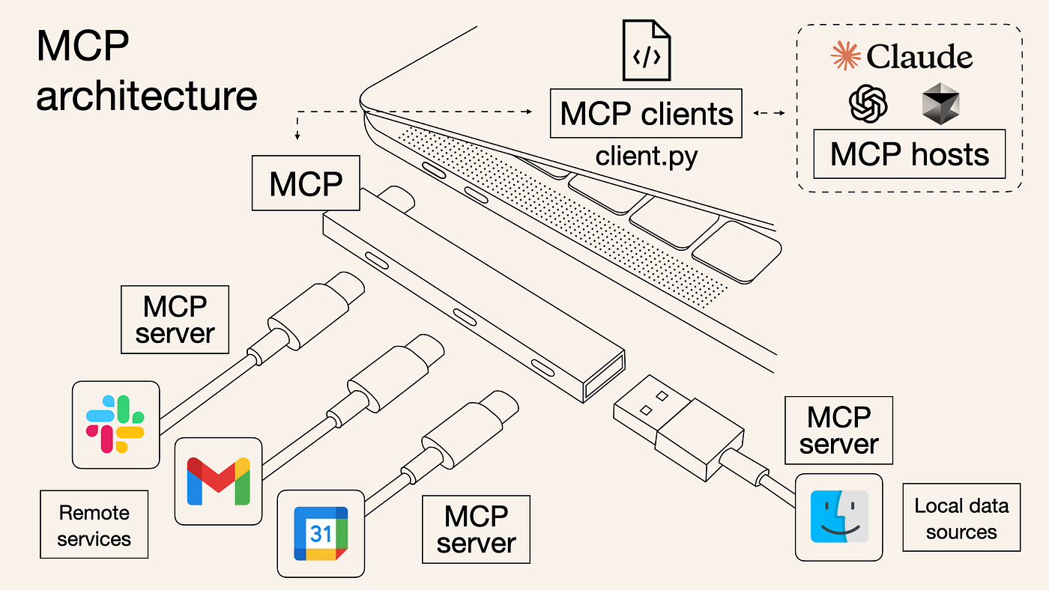

Analogy

* MCP is like a **USB-C port for AI applications**.
* Without MCP, developers had to integrate multiple APIs (Google, Slack, Calendar, etc.), each with its own authentication, format, and quirks—similar to having different chargers for every device.
* This made building AI applications cumbersome because developers had to write extensive custom code for each integration.

What MCP Does

* MCP acts as a **universal adapter** between AI models (LLMs) and external tools/services.
* Instead of coding for each API individually, developers can use MCP servers provided by vendors.
* The AI model sends generic requests to MCP, which translates them into specific API calls for the target service.

### WHAT IS MODEL

* A model in AI is like a **smart brain** trained to perform specific tasks such as understanding text, recognizing images, or making decisions
* Data always has patterns.Models learn patterns from large datasets and use them to make predictions. Example: Predicting house prices based on size, detecting spam emails, or recommending courses.

Types of Models

**Predictive Models:**

* House price prediction (regression).
* Spam vs. not spam (classification).
* Recommendation systems (clustering).

**Generative Models:**

* Large Language Models (LLMs) like **ChatGPT, Claude, Gemini**.
* Trained on massive text corpora to understand and generate human language.

Large Language Models (LLMs)

Advanced AI models using **deep learning** and **transformer architecture**. The core capabilities:

* Translation
* Summarization
* Question answering
* Conversational fluency
* LLMs provide **generative AI capabilities**, unlike traditional predictive models.

### WHAT IS CONTEXT

* For AI models, context refers to extra **structured information** that helps to interact with external systems.
* MCP organizing context into **three components**:

Tools

* Functions or actions the AI model can invoke. Examples: Querying a database, sending an email.
* Each MCP server provides its own set of tools.

Resources

* Structured, often read-only data the model can access.
* Examples: Files, database views, API endpoints.

Prompts

* Predefined templates or workflows guiding AI interactions.
* Often combine tools and resources for complex tasks.

**Context = Tools + Resources + Prompts → Enables AI models to work seamlessly with external systems via MCP.**

### WHAT IS PROTOCOL

## EVOLUTION OF MCP

### LLMs

* Initially, we had **Large Language Models (LLMs)** like ChatGPT, LLaMA, and Gemini. These were amazing—they could write stories, poems, summarize text, and answer questions. But they worked in isolation. They only knew what they were trained on, up to a certain date. So if we asked for something recent, like today’s stock price or weather, they couldn’t help. That was the first limitation.

### **LLM + TOOLS:**

|  |  |
| --- | --- |
|  | * **Then came the next step: LLM + Tools: OpenAI** introduced **function calling**, and frameworks like LangChain added **tool use**. This allowed LLMs to call external APIs. For example, if we asked, “What’s the weather in London?” the model could call a weather API and give the answers. * This was the beginning of **agentic behavior**—models taking actions. But there was a problem: **every integration was hard-coded. If you needed 10 APIs, you wrote 10 separate integrations. It was complex, hard to maintain, and not scalable.** |

### MODEL CONTEXT PROTOCOL

|  |  |
| --- | --- |
|  |  |

* This changed everything. MCP acts like a **universal adapter** or a **USB-C port for AI**.
* So instead of calling tools directly the LM sends the request through the MCP or Model Context Protocol,
* which acts as a gateway.
* The advantage was it decouples the LLM from the tool logic. So, the LLM doesn't have to worry about what is going on in the backend services.This **decouples the LLM from backend logic**, making integrations standardized, reusable, and scalable. It also improves security and observability.

|  |
| --- |
| * In the modern MCP architecture – our computer acts as an **MCP host**, which communicates with multiple **MCP servers**. Each server knows how to talk to its specific service—Azure, PayPal, or a local database. So now, LLMs can interact with **live data, APIs, and systems** in a controlled and secure way. |

## ANTHROPIC ,CLAUDE AND MCP

* **Anthropic** is an AI research and development company focused on building safe and reliable AI systems.
* **Claude** is Anthropic’s family of **Large Language Models (LLMs)**, like ChatGPT i.e. just like OpenAI has ChatGPT, Anthropic has Claude.
* **MCP (Model Context Protocol) is an open standard developed by Anthropic to standardize how AI models (like Claude) interact with external tools, APIs, and data sources.**

## WHY MCP WAS NEEDED?

Before MCP, AI applications used **REST APIs** to connect to tools/external services (provided by 3rd Party service providers). This approach has several challenges:

|  |  |
| --- | --- |
|  | Problems with REST APIs Implementation:   1. **Tight coupling**: Any change in the tool’s API required changes in the client code. 2. **Maintenance overhead**: Frequent updates from third-party tools meant constant refactoring. 3. **Scalability issues**: Integrating multiple tools require custom logic for each. |

## HOW MCP SOLVES THESE PROBLEMS?

Anthropic introduced a **standardized protocol layer** between the AI model and external tools called MCP

**Instead of:** LLM → REST API → Tool

**Now:** LLM → MCP Protocol → Tool

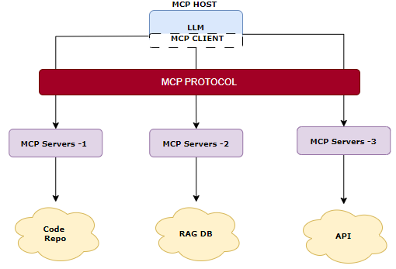

Instead of accessing the tool via rest API, LLMs will be accessing the tools using MCP

Benefits:

* **Loose coupling**: Tools can evolve independently.
* **Plug-and-play**: New tools can be added without changing client logic.
* **Standardization**: All tools follow the same protocol format.

## MCP IN GENERATIVE & AGENTIC AI APPLICATIONS

Example

* Let’s say we are building an **AI assistant** that answers user queries. For that it might need access to various 3rd party services like Wikipedia, A vector database or a search engine
* **With REST APIs**
  + We need to write custom code for each tool.
  + If the tools (Wikipedia) change their API, we must update our code.
  + Every tool had a different format, making integration complicated.
* **With MCP:**
  + We can connect all tools via MCP.
  + **No need to change our code when tools update — because those service providers will be adhered to MCP standards.**

### WORKFLOW

* **REST API Workflow:** User → AI Assistant → Wikipedia API (REST) → JSON Response → Display
* **MCP Workflow:** User → AI Assistant → MCP Protocol → Wikipedia Tool → Standardized Response → Display

# MCP ARCHITECTURE AND COMPONENTS

|  |
| --- |
| * MCP (Model Context Protocol) is not just another protocol—it’s a **flexible, modular bridge** that connects AI models to their runtime environments and external tools in a structured way. It makes communication between models and services **standardized, scalable, and secure**.   Core Design  At its core, MCP uses a **client-server model**:   * **Client**: Sends requests with context (what the model wants to do). * **Server**: Processes the request and sends back a response. * Communication happens using **JSON-RPC 2.0**, which is a lightweight protocol for remote procedure calls using JSON. This ensures requests and responses are structured and easy to parse.   Key Components  MCP has three main building blocks:   1. **MCP Server** – Hosts the logic for actions or tools (e.g., querying a database, sending an email). 2. **MCP Client** – Sends requests and handles responses. 3. **Transport Layer** – Handles how data flows between client and server.   Transport Layer Options  This is how requests and responses move:   1. **Stdio (Standard Input/Output)** – Simple and fast for two processes to talk. 2. **Server-Sent Events (SSE)** – Allows real-time data push from server to client (though may be deprecated). 3. **Streamable HTTP (Recommended)** – Scalable and stateless, ideal for web-based interactions. |

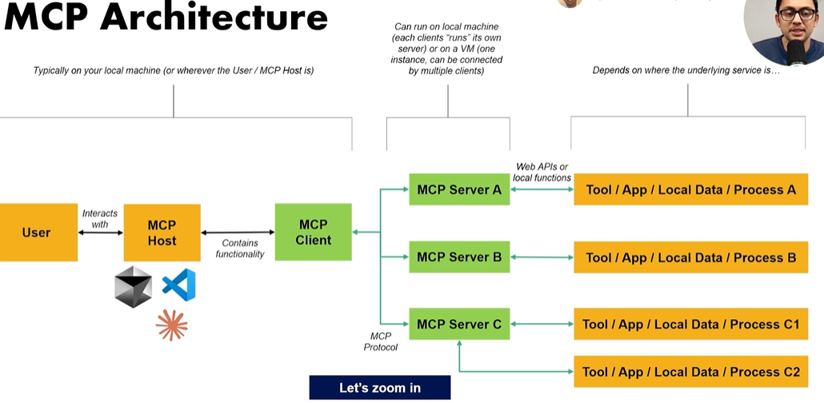

* **MCP Client**
  1. Acts as the **requester**—this could be a tool(like VS Code , Claude desktop, Cursor) or an assistant (for example, a coding assistant). It sends requests asking for data or actions.
* **MCP Server**
  1. Acts as the **responder**—it fetches the requested data from the designated source or performs the required action.
* **MCP Protocol**
  1. Provides a **standard communication format** between the client and the server. This ensures structured, consistent interaction.
* **Data Sources: Can** be various types, such as:
  1. Local file systems
  2. Databases
  3. Third-party APIs

## KEY COMPONENTS OF MCP

1. MCP Client
2. MCP HOST
3. MCP Server

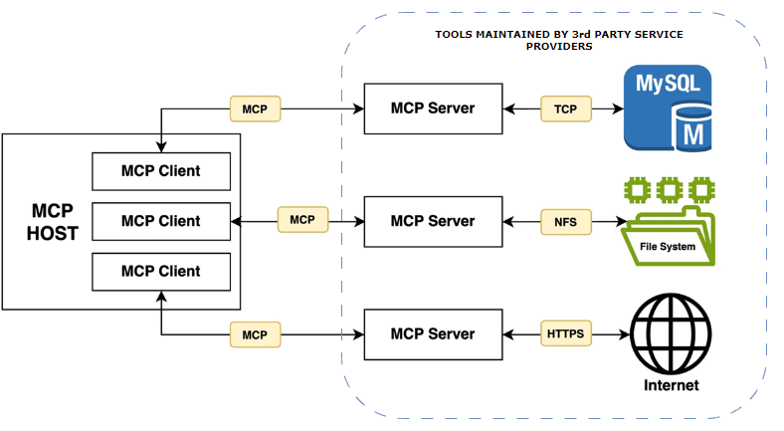

### MCP HOST

* An **MCP host** is essentially any application or framework that embeds an **MCP client**
* It’s an application that **implements an MCP client internally**.
* Its role is to **connect to MCP servers** and exchange context, tools, and capabilities.
* Enabling MCP Client to communicate using the Model Context Protocol (MCP).

Common MCP Hosts

These are widely used environments where MCP clients are integrated:

* **VS Code** – Often used with extensions that leverage MCP for AI-assisted coding.
* **Anthropic Cloud** – Provides hosted AI services with MCP integration.
* **Cursor** – A developer-focused IDE that uses MCP for contextual AI features.

Other Frameworks That Can Act as MCP Hosts

Beyond the common ones, several frameworks can serve as MCP hosts because they embed MCP clients:

* **OpenAI Agents SDK** – Allows developers to build agent-based applications that communicate via MCP.
* **LangGraph** – A graph-based orchestration framework that can host MCP clients for multi-agent workflows.
* **Others** – Any application or framework that integrates MCP client logic can qualify (e.g., custom orchestration tools, AI pipelines).

### MCP CLIENT

* MCP client is basically a class or an object that allows the MCP host to communicate with MCP Servers.
* The communication between MCP server and MCP Client is called MCP protocol.

**The protocol used for the communication between MCP host and MCP server is Model Context Protocol**

### MCP SERVER

* An **MCP server** is a modular component that exposes **tools, apps, local data, and processes** to an MCP client (inside an MCP host).
* It acts as the bridge between the LLM and external capabilities.

#### KEY CHARACTERISTICS

**One-to-One Design Principle**

* Typically, an MCP server is designed to connect to **one specific tool, app, or process** for modularity.
* This means if our application only needs Slack functionality, we connect to the Slack MCP server—not Slack + Dropbox + Gmail together.
* However, Multi-Tool Servers Exist - Some servers expose multiple tools for convenience. For example,
  + **Airbnb MCP server** →
    - Tool 1: Search listings
    - Tool 2: Get detailed listing data
  + **Slack MCP server** →
    - Tools: list channels, send message, reply, view user profile, etc.

**STEP-BY-STEP MCP WORKFLOW USING YOUR WEATHER EXAMPLE**

**Scenario:** User says:*“I need the weather for New York City for tomorrow.”*

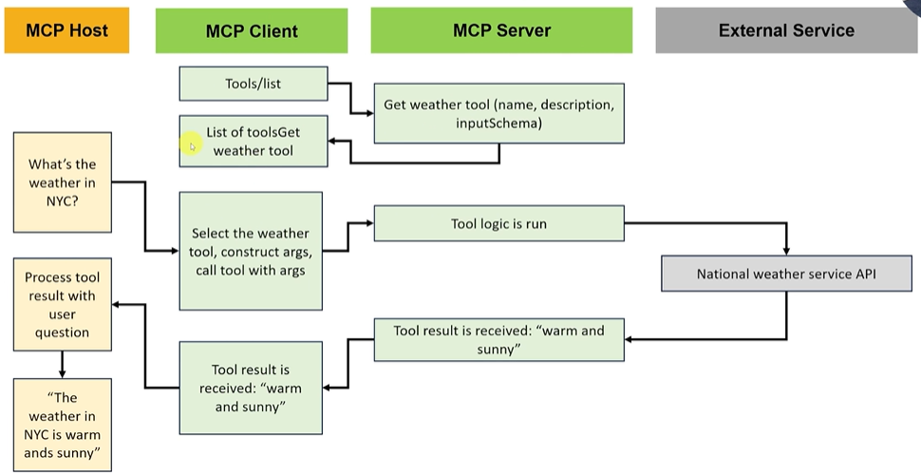

Step 1: User Request Reaches MCP Host

* The **MCP host** (e.g., VS Code, Cursor) receives the user’s natural language request.
* The host knows it has an **MCP client** and a **list of available tools** (from connected MCP servers).

Step 2: MCP Host Lists Tools to the LLM

* The MCP client sends the LLM a **catalog of tools** it can call.  
  Example tools:
  + GetWeather
  + SearchListings
  + SendSlackMessage

Step 3: LLM Chooses the Right Tool

* The LLM interprets the user’s intent: *“weather for New York City”*.
* It finds a matching tool: **GetWeather**.
* It decides to call this tool and prepares the **arguments**:
  + location = "New York City"
  + date = "tomorrow"

Step 4: MCP Client Executes Tool Call

* The MCP client handles the logic for calling the MCP server:
  + It sends a request to the **MCP server** hosting the GetWeather tool.
  + Includes arguments: New York City, tomorrow.

Step 5: MCP Server Processes Request

* Inside the MCP server:
  + Logic connects to a **Weather API** (e.g., National Weather Service).
  + Passes the arguments, performs any transformations or searches.
  + Gets a response: > "Warm and sunny"

Step 6: Response Flows Back

* MCP server → MCP client → LLM:
  + The MCP client receives "Warm and sunny" and sends it to the LLM.

Step 7: LLM Generates Final Answer

* The LLM combines:
  + User’s original request
  + MCP server’s response
* Produces a natural language reply: > *“Tomorrow in New York City, it will be warm and sunny.”*

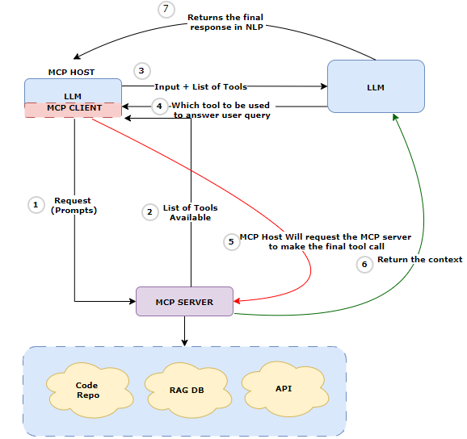

### TOOLS

* Tools are Model controlled.
* These are the functions the model can invoke via the client.
* Examples: Retrieve latest documents, Send a message or email, Update database records

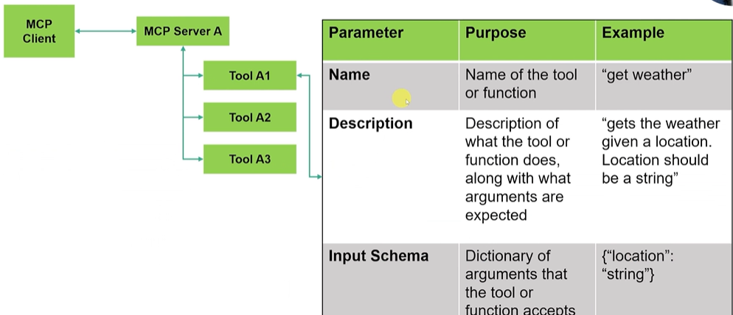

#### DEFINING A TOOL

Every tool in an MCP server needs **three key parameters**:

|  |  |  |
| --- | --- | --- |
| **NAME** | 1. Unique identifier for the tool (e.g., getWeather). 2. Can be:    * **Static**: Hardcoded when creating the tool.    * **Dynamic**: Derived from the function name. | |
| **DESCRIPTION** | 1. Explains what the tool does and what arguments it expects. 2. Can be:    * **Static**: Written explicitly.    * **Dynamic**: Derived from the function’s docstring. | |
| **INPUT SCHEMA** | * Dictionary of arguments the tool accepts. * It can also be **inferred from function signatures** (e.g., Python type hints). | Example:  **{**  **"type": "object",**  **"properties": {**  **"location": { "type": "string"},**  **"date": {"type": "string"}**  **},**  **"required": ["location"]**  **}** |

#### WHY THESE PARAMETERS MATTER

* The **MCP client** and **host** use:
  + **Name** + **Description** → To decide which tool to call.
  + **Input Schema** → To validate and pass correct arguments.

### RESOURCES

* In MCP, **resources** are pieces of contextual data that an MCP server exposes to clients.
* They provide additional information that helps AI models make better decisions or generate more accurate outputs.
* Resources act like **reference material** for the AI. They don’t execute anything but provide context so the model can produce better results.
* Examples of resources:
  + **Files** (e.g., source code, documentation)
  + **Database schemas**
  + **Application-specific metadata**
  + **Design assets** (e.g., Figma components)

Example

* You have an MCP server that exposes **project documentation** as a resource for Copilot.
* This allows Copilot to read the documentation and use it when answering questions or generating code.

**Step 1: Define the Resource**

In the MCP server manifest, you declare a resource called ProjectDocs:

{

  "resources": [

    {

      "uri": "resource://project/docs",

      "name": "Project Documentation",

      "description": "Contains architecture and API details for Project X",

      "mimeType": "text/markdown"

    }

  ]

}

**URI**: Unique identifier for the resource.

**mimeType**: Tells the client the format (Markdown in this case).

**Step 2: Client Requests the Resource**

Copilot sends a resources/read request:

{

  "method": "resources/read",

  "params": {

    "uri": "resource://project/docs"

  }

}

**Step 3: Server Responds**

The MCP server returns the content:

{

  "result": {

    "content": "# Project X API\n\nBase URL: https://api.projectx.com\n\nEndpoints:\n- GET /users\n- POST /orders"

  }

}

**How Copilot Uses It**

Now, when you ask Copilot:\ **“Write a Python function to call the Project X API and fetch users.”**\ Copilot uses the resource content to generate accurate code:

import requests

def get_users():

    response = requests.get("https://api.projectx.com/users")

    return response.json()

``

### PROMPTS

* Prompts are **predefined instruction templates** that MCP servers provide to guide the LLM’s behavior when interacting with tools or resources.
* **Examples of Prompts**:
  + A **system prompt** for summarizing Slack messages.
  + A **template** for generating an email reply.
  + A **structured query prompt** for searching a database.
* Prompts standardize how the LLM interacts with tools/resources, ensuring consistency and reducing errors.

|  |  |
| --- | --- |
| **TOOLS** | Perform actions (API calls, computations). |
| **RESOURCES** | Provide context or data for reasoning. |
| **PROMPTS** | Guide the LLM on how to use tools and resources effectively. |

## WHAT IS JSON RPC -2.0

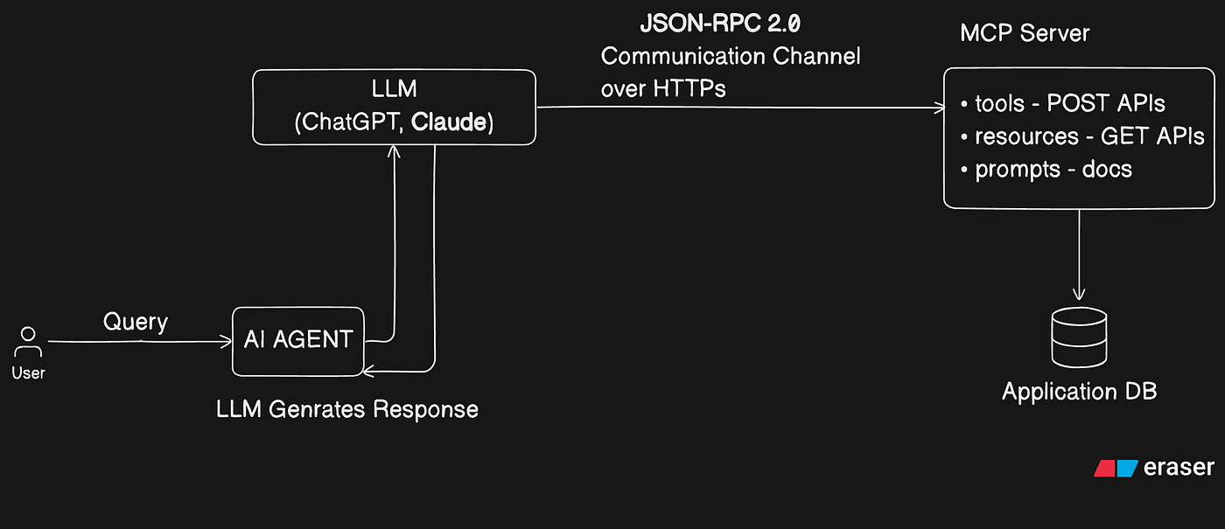

What is JSON-RPC 2.0 and Why MCP Uses It?

* MCP (Model Context Protocol) is a set of rules for how AI models interact with external tools and services. **Under the hood, MCP uses JSON-RPC 2.0 as its communication protocol.**
* **JSON-RPC 2.0** is a lightweight, standardized protocol for **remote procedure calls** using JSON.
* It defines how a client and server exchange structured messages for invoking methods and returning results. So, JSON-RPC means calling remote functions using JSON messages.

What New in Version 2.0?

JSON-RPC 2.0 is the most widely used version because it adds:

* Notifications (fire-and-forget calls, no response needed)
* Batch requests (send multiple calls in one request)
* Standardized error handling

Key Features

* Uses JSON as data format for request and response. **Every request includes the method name, optional parameters and an ID**
* **Lightweight & Language Agnostic**: Works with any language that supports JSON (Python, Java, C#, etc.).
* **Client-Server Model**: Perfect for MCP, where the client sends requests and the server responds.
* **Structured Communication:** Both request and response are in JSON format.

How It Looks

|  |  |
| --- | --- |
| **Response Example** | **Response Example** |
| {    "jsonrpc": "2.0",    "method": "getWeather",    "params": { "city": "San Francisco" },    "id": 1  } | {    "jsonrpc": "2.0",    "result": { "temperature": "18°C", "condition": "Partly Cloudy" },    "id": 1  } |
| In the request-response structure - **Every request includes the method name, optional parameters and an ID. The ID should match in both request and response.**   * Method name: The function to call (e.g., getWeather) * Params: Arguments for the method * ID: Matches request and response * Response object contains the result(success)or error(failure) | |
|  | |

Client-Server Interaction

1. **Client → Server:** Sends a **request** to invoke a method (e.g., call a tool or query data).
2. **Server → Client:** Sends a **response** with the result or an error.
3. **Notification:** Fire-and-forget messages (no response expected), often used for progress updates.

## MCP TRASPORT LAYER

* The transport layer in MCP is responsible for **how messages move between the client and server**.
* It ensures that communication is smooth, standardized, and flexible across different environments.

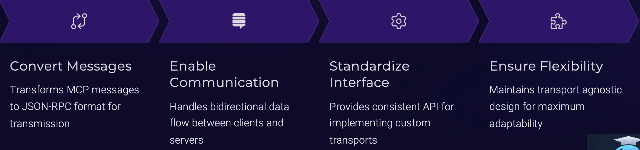

|  |  |  |  |
| --- | --- | --- | --- |
| Convert Messages   1. Converts MCP protocol messages into **JSON-RPC 2.0 format** for transmission. 2. Converts JSON-RPC responses back into MCP-compatible messages for the AI model. 3. Example: Client sends MCP request → Transport converts to JSON-RPC → Server responds → Transport converts back. | Enable Communication   * Handles the mechanics of sending and receiving messages. * Ensures requests, responses, and notifications flow correctly between client and server. | Standardize Interfaces   * Provides a consistent API-like interface for developers. * Regardless of the transport method (Stdio, HTTP, SSE), the interaction remains uniform. | Ensure Flexibility   * Supports multiple transport mechanisms: |

### TRANSPORT MECHANISM – STDIO(STANDARD I/O) FOR LOCAL COMMUNICATION

* STDIO **uses the operating system’s standard input and output streams for communication** between two processes on the same machine.
* Example: When we run an AI model locally and start an MCP server as another process.

1. **The MCP client writes a JSON-RPC request to stdout**.
2. **The MCP server reads it from stdin, processes it, and writes the response back to stdout.**

**Example Flow: Client → stdout → Transport → stdin → Server**

Where It Can Be Used

1. Building Command line Tool
   1. STDIO transport mechanism can be used to build CLI, which can communicate with a AI model using a command line interface.
2. Implementation of local integration
   1. STDIO is the simplest transport method in MCP. It uses local computer’s **standard input and output streams** to let two processes talk to each other.
   2. This is perfect for **local integrations** where everything runs on the same machine.
   3. **Example Scenario - Imagine** we’re building a **desktop note-taking app** that works offline. We want to add an **AI summarization feature** so users can summarize their notes without internet access.

How it works?

* A note-taking app act as the **MCP client**.
* The AI summarization model runs as a **local MCP server**.
* They communicate using **STDIO**:
* The client sends a summarization request through **stdout**.
* The server reads it from **stdin**, processes it, and sends the summary back through **stdout**.

1. Benefits

* Fast and simple for local setups.
* No network overhead.

### TRANSPORT MECHANISM – SSE- SERVER SENT EVENT (REAL TIME UPDATES)

* **SSE** stands for **Server-Sent Events**.
* It’s a way for the **server to send updates to the client in real time**.
* **Think of it as one-way streaming: from server → client**.
* The client doesn’t keep asking for updates; the server pushes them automatically.

How does it work in MCP?

* MCP uses **HTTP POST** for client → server requests.
* For **server → client updates**, MCP uses **SSE**.
* Example:
  + Client sends a request (e.g., “Start summarizing”).
  + Server processes it and **streams progress or results back** using SSE.

|  |
| --- |
| **SSE-based approach in MCP required two endpoints.**   1. **One endpoint for HTTP POST** → This handled **client-to-server communication** (sending JSON-RPC requests). 2. **Another endpoint for SSE (Server-Sent Events)** → This handled **server-to-client streaming** (sending real-time updates back to the client). |

When do we use SSE?

* **REAL-TIME UPDATES**
  + Example: An AI assistant showing **live stock prices**.
  + Server streams price changes to the client as they happen.
  + Client doesn’t need to poll the server repeatedly.
* **RESTRICTED NETWORKS**
  1. SSE works over **standard HTTP**, so it’s great for corporate environments with strict firewalls.
  2. Example: An AI assistant in a company still gets updates even if non-HTTP protocols are blocked.
* **SIMPLE NOTIFICATIONS**
  1. Ideal for apps that need **basic real-time alerts** without complex two-way communication.
  2. Example: An AI-powered **news aggregator** sending breaking news alerts to users.

Why SSE is useful

* Efficient for **server-to-client streaming**.
* Works in environments where **WebSockets or other protocols are blocked**.
* Perfect for **real-time notifications** without heavy setup.

SSE in MCP is like the server saying:*"I’ll keep you updated as things happen, you don’t need to ask me every time."*

### TRANSPORT MECHANISM – STREAMABLE HTTP (REMOTE COMMUNICATION)

|  |
| --- |
| Streamable HTTP is the **modern transport mechanism for MCP**, introduced in **March 2025**. It replaces the older **two-endpoint SSE approach** with a **single unified endpoint** for both sending requests and receiving responses. |

How Does It Work?

**Uses one HTTP endpoint instead of two** (**unlike SSE)**

1. **Client → Server:** Sends JSON-RPC requests (or batches) via **HTTP POST**.
2. **Server → Client:** Streams responses or notifications back using **Server-Sent Events (SSE)** over the **same endpoint**.

**This means bidirectional streaming happens through one endpoint, making it simpler and more efficient.**

Where Do We Use It?

* When your MCP server runs on a **cloud VM** or remote environment.
* Example:
  + MCP server running in Azure or AWS.
  + Client connects to it using **Streamable HTTP** for both sending requests and receiving real-time updates.
* HTTP is the same protocol your browser uses. It’s ideal for communication between systems over a network.

|  |  |  |
| --- | --- | --- |
| **Example Scenario:** MCP server runs in the cloud, and your client is on your laptop. | The client sends a JSON-RPC request via **HTTP POST:**  **POST https://mcp-server.com/api**  **{**  **"jsonrpc": "2.0",**  **"method": "getWeather",**  **"params": { "city": "San Francisco" },**  **"id": 1**  **}** | The server responds with JSON over HTTP.  Why use it?   * Works across networks. * Easy to integrate with web services. |

## HOW MCP CLIENT CONNECTS TO MCP SERVER

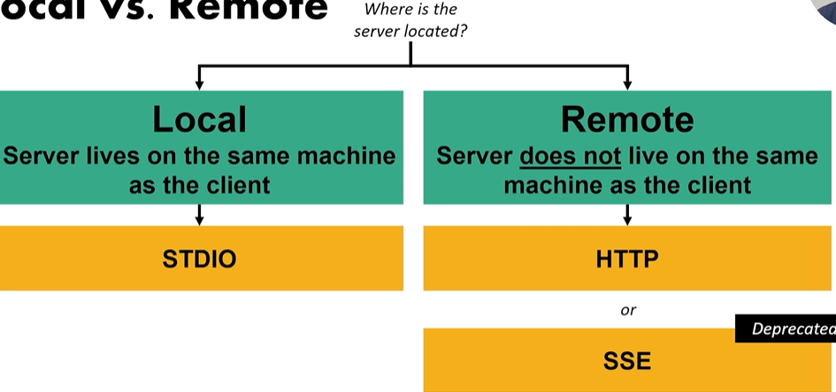

The protocol depends on **where the MCP server is located** i.e. ***Locally or Remote***

### LOCAL DEPLOYMENT

* **In local deployment** MCP server runs **on the same machine** as the MCP client.
* In this case, we use STDIO (Standard I/O) as our MCP Protocol
* There is 1:1 mapping between server & client

How it works

|  |  |
| --- | --- |
| * In local deployment, we give a configuration script to the MCP client that teaches MCP client how to run the MCP server. * The client downloads, installs and runs the server as a **subprocess** using a config script. |  |

### REMOTE DEPLOYMENT

|  |  |
| --- | --- |
|  | * MCP server runs on a **remote VM or cloud instance**. * **It uses HTTP protocol for MCP client -server communication** * In this set up – we an have one remote MCP server and multiple MCP clients can connect with it. * The MCP servers are implemented by the service provider itself |

* **How it works**:
  + MCP client connects via **HTTP** (Server-Sent Events was an option but deprecated in 2025).
  + One remote MCP server can serve **thousands of clients**.
* **Benefits**:
  + Centralized updates → only one server needs updating.
  + Offloads heavy computation from local machines.
  + Easier portability and integration with online MCP hosts.
* **Considerations**:
  + Requires **authentication** (OAuth or tokens).
  + Network security and encryption are critical.

# MCP ENVIRONMENT SET UP

* VS Code -IDE
* Python
* MCP Client like Claude Desktop – used mainly to test the application

## uv VERSUS pip

|  |  |
| --- | --- |
| Pip | Uv |
| * **Purpose:** The default Python package installer. * **How it works:** Downloads packages from PyPI and installs them into environment. * **Features:**   + Simple and widely used.   + Works with requirements.txt.   + Slower for large dependency trees because it installs packages sequentially. * **Limitations:**   + No built-in lock file support.   + Dependency resolution can be slow and sometimes inconsistent. | * **Purpose:** A modern Python package manager designed for **speed and reproducibility**. * **Key Features:**   + **Ultra-fast installs** (parallelized and optimized).   + **Lock file support** for deterministic builds.   + **Better dependency resolution** than pip. * Can manage **virtual environments** and **Python versions** (like pipenv or poetry). * **Why use it?**   + Ideal for large projects or CI/CD pipelines where speed and reproducibility matter.   + Integrates well with modern workflows. |

# PROJECT SET UP

**NOTE – We will use “uv” to manage the project like (project initialization , dependency installation & executing project)**

### INITIALIZE PROJECT

**uv COMMANDS TO CREATE PROJECT AND VIRTUAL ENV**

|  |  |
| --- | --- |
| **INSTAL UV** | **curl -LsSf https://astral.sh/uv/install.sh | sh** |
| uv init <project_name> | To Initialize the project |
| uv venv | Creates a Virtual environment(.venv) |

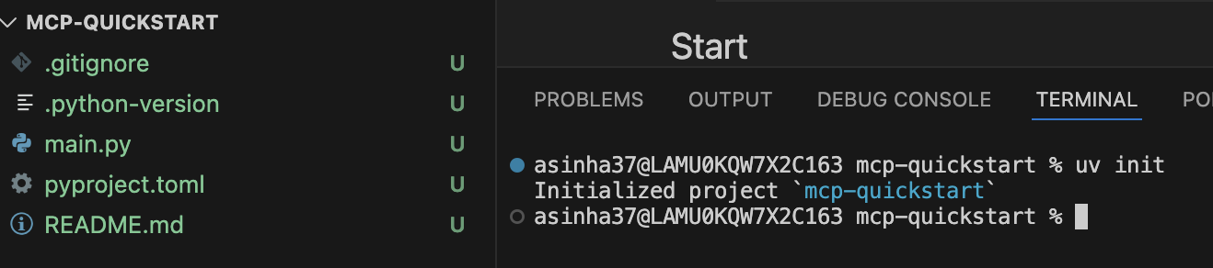

### INSTALL DEPENDENCIES USING UV

|  |  |
| --- | --- |
| **INSTALL MCP CLI PACKAGE** | uv add ‘mcp[cli]’ |

# MCP SERVER

STEP 4: Create a new file to create a new MCP server (**weather.py**)

|  |
| --- |
| from mcp.server.fastmcp import FastMCP  mcp = FastMCP("Weather")  @mcp.tool()  def get_weather(location: str) -> str:  """  Fetches the current weather for a given location.  Args:  location (str): The location to get the weather for.  Returns:  str: A string describing the current weather.  """  # Placeholder implementation  return f"The current weather in {location} is sunny with a temperature of 25°C."  if __name__ == "__main__":  mcp.run() |

|  |
| --- |
| * **FastMCP** belongs to the **MCP SDK ecosystem**. * **FastMCP** is a lightweight, high-performance implementation of the **Model Context Protocol** designed for developers who want to quickly build MCP servers and clients. * It is part of the **official MCP SDK family**, which provides tools and libraries for implementing MCP features like:   + JSON-RPC 2.0 messaging   + Transport layers (Stdio, HTTP, Streamable HTTP)   + Tools, Resources, and Prompts management |

|  |  |
| --- | --- |
| * Initializes an MCP server with the name **"Weather"**. * This name is used to identify the service when interacting with clients or other systems. | mcp = FastMCP("Weather") |
| * **Decorator** @mcp.tool(): This registers the function **get_weather** as a tool in the MCP server. * Tools are callable endpoints that clients can invoke. * **Function Signature :**   + location: str → The input parameter is typed as a string.   + str → The function returns a string. * **Docstring:** Explains what the function does, its arguments, and return type. This is useful for documentation and sometimes for auto-generated schemas. * **Note:** Currently, it’s a **placeholder** that returns a hardcoded weather description. In a real-world scenario, this would call an API (like OpenWeatherMap) to fetch live data. | @mcp.tool() |
| This starts the MCP server so it can listen for requests from clients.  mcp.run() handles:   * Initializing the server. * Exposing registered tools (like get_weather) via MCP protocol. * Managing communication with clients. | if **name** == "**main**":      mcp.run() |

## TESTING MCP SERVER USING MCP INSPECTOR

* To test the MCP server – we need start the MCP server in development mode.
* **COMMAND**: **mcp dev weather.py 🡪** It runs your MCP server (weather.py) in **development mode**.
* **This will spin up a MCP Client GUI called MCP inspector**

|  |
| --- |
| **Development Mode Features:**   * Hot reloading: Automatically restarts the server when you change the code. * Debugging: Provides verbose logs for troubleshooting. * Tool inspection: Allows you to test and validate your MCP tools interactively. |

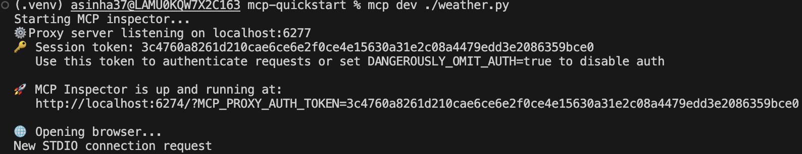

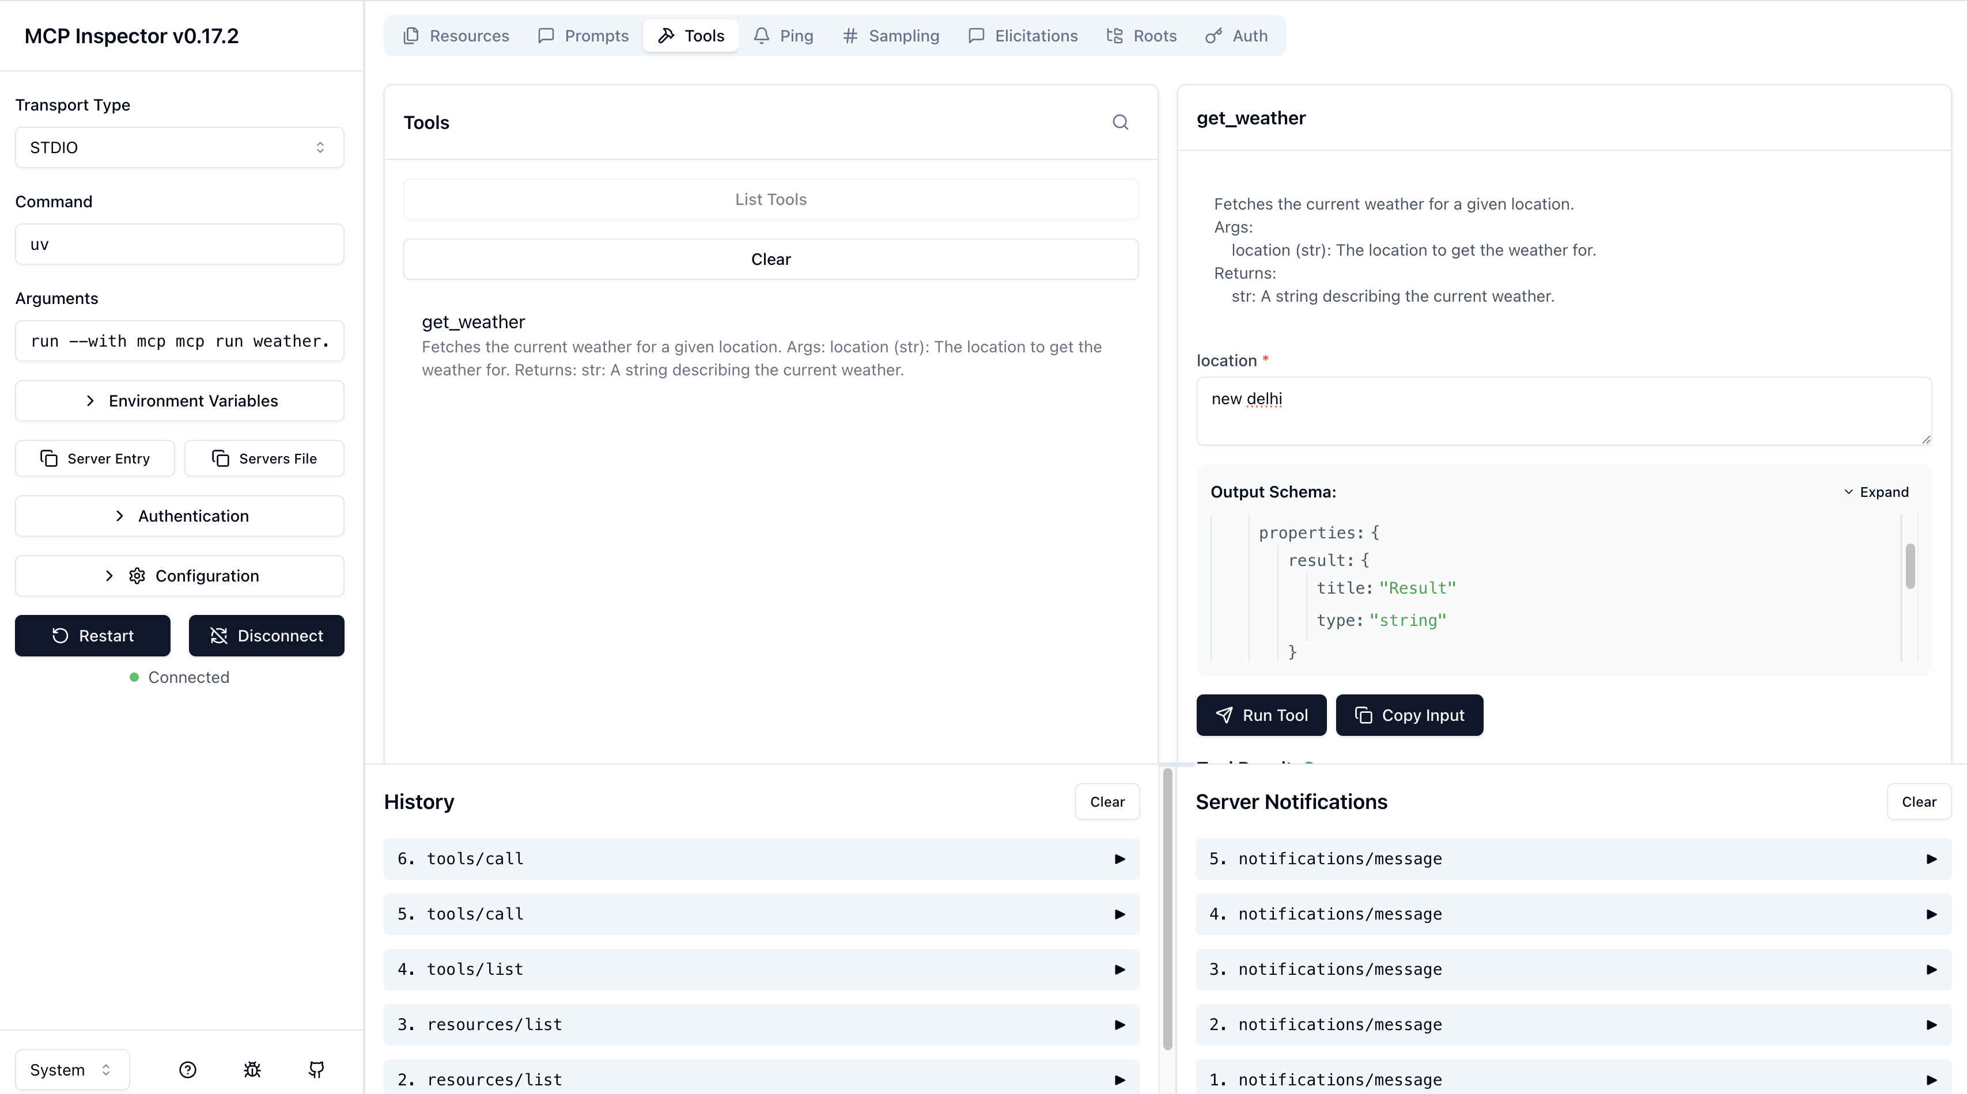

## TESTING MCP SERVER USING VS CODE AS HOST/CLIENT

|  |  |
| --- | --- |
| * Create a “mcp.json” file in .vscode folder * Start the MCP server |  |
| {  "servers": {  "weather": {  "command": "uv",  "args": [  "--directory",  "/Users/asinha37/code/MCP/mcp-quickstart",  "run",  "weather.py"  ]  }  }  } | |

|  |
| --- |
| Purpose Of mcp.json   * It defines how VS Code (or any MCP client) should **start and connect to an MCP server** called weather.   What Happens When VS Code Uses This?   1. VS Code reads mcp.json. 2. It launches the weather MCP server by running: **uv --directory /Users/asinha37/code/MCP/mcp-quickstart run weather.py** 3. The MCP client in VS Code then communicates with this server (usually via **Stdio**) to access tools defined in weather.py (e.g., fetching weather data). |

* Starting the MCP server from VScode will list in available tools – Hence we can trigger MCP tool from copilot chat

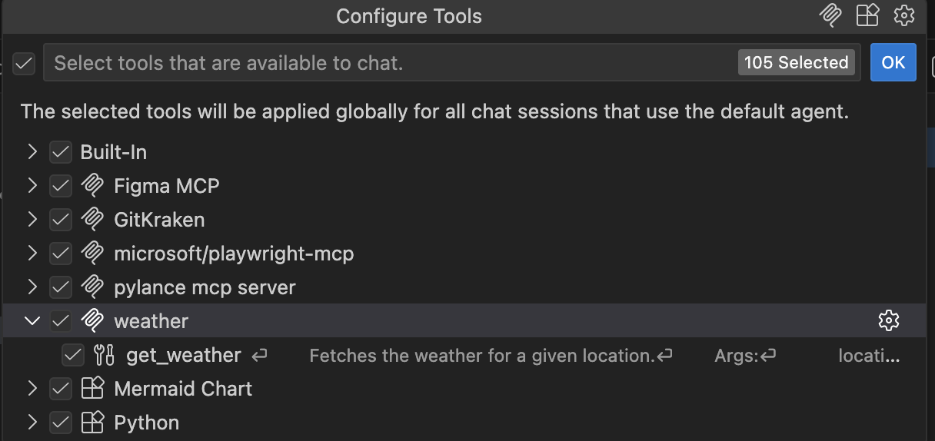

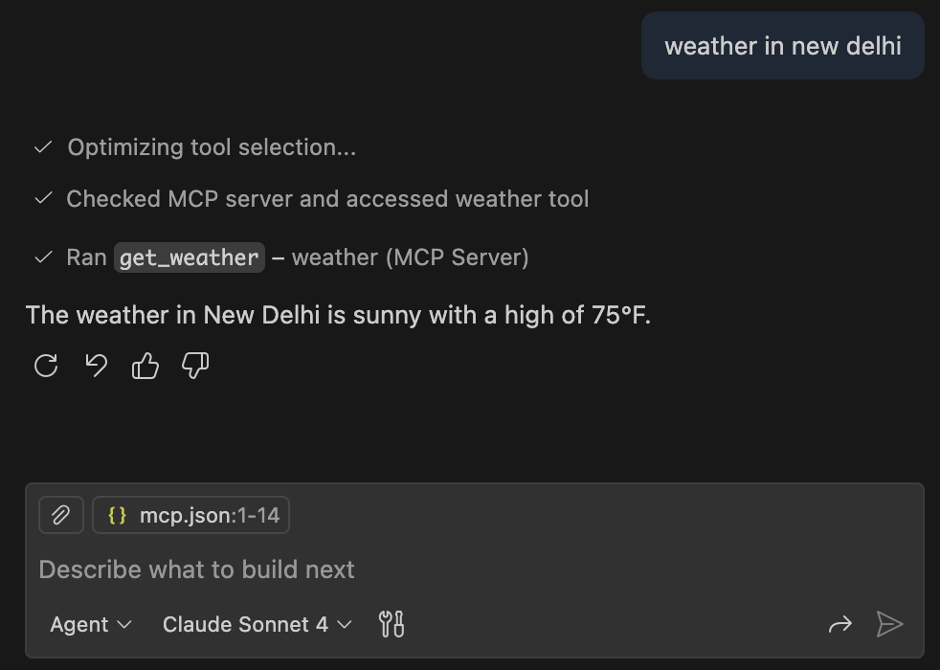

|  |
| --- |
| NOTE  The application like **VS Code acts as an MCP host**, and here’s how the roles are divided:  VS Code as MCP Host  The **host** is the environment that:   * + Loads the MCP **client logic**.   + Reads the mcp.json configuration file.   + Starts and manages MCP servers (local or remote).   + Handles communication between the AI model (like Copilot) and MCP servers using MCP protocol.   + So, **VS Code = MCP Host** because it orchestrates everything.   Where is the MCP Client?  The **MCP client** is **inside VS Code** (as part of the Copilot or MCP integration).  It:   * + Reads mcp.json to know which servers to connect to.   + Sends **JSON-RPC requests** to MCP servers.   + Receives responses and streams updates back to VS Code features (like AI assistance).   Flow  **VS Code (MCP Host)**  **|**  **└── MCP Client (built-in)**  **|**  **└── Transport (Stdio / HTTP / Streamable HTTP)**  **|**  **└── MCP Server (e.g., weather.py)** |

# MCP CLIENT

## CREATING MCP CLIENT USING MCP PYTHON-SDK - STDIO

In this example- we will create client (using python) that

1. **COMMUNICATES WITH A SERVER**
2. **LISTS THE TOOLS**
3. **CALLS THE TOOLS**

|  |
| --- |
| from mcp import ClientSession, StdioServerParameters  from mcp.client.stdio import stdio_client  import asyncio  import traceback  server_params = StdioServerParameters(  command="uv",  args=["run","weather.py"],  )  async def run():  print("Starting Weather Client...")  async with stdio_client(server_params) as (read, write):  try:  async with ClientSession(read, write) as session:  print("Initializing session...")  await session.initialize()    print("Listing tools...")  tools = await session.list_tools()  print("Available tools:", tools)    print("Invoking get_weather tool...")  result = await session.call_tool("get_weather", arguments={"location": "San Francisco"})  print("Weather Result:", result)  except Exception as e:  print("An error occurred:", e)  traceback.print_exc()  if __name__ == "__main__":  asyncio.run(run()) |

|  |  |
| --- | --- |
| RUNNING MCP CLIENT | **uv run client.py** |

OUTPUT

|  |
| --- |
| (helloworld) asinha37@LAMU0KQW7X2C163 helloworld % **uv run client.py**  Starting Weather Client...  Initializing session...  Listing tools...  [11/23/25 16:08:52] INFO Processing request of type ListToolsRequest server.py:674  Available tools: meta=None nextCursor=None tools=[Tool(name='get_weather', title=None, description='Get the current weather for a given location.', inputSchema={'properties': {'location': {'title': 'Location', 'type': 'string'}}, 'required': ['location'], 'title': 'get_weatherArguments', 'type': 'object'}, outputSchema={'properties': {'result': {'title': 'Result', 'type': 'string'}}, 'required': ['result'], 'title': 'get_weatherOutput', 'type': 'object'}, icons=None, annotations=None, meta=None)]  Invoking get_weather tool...  INFO Processing request of type CallToolRequest server.py:674  Weather Result: meta=None content=[TextContent(type='text', text='The current weather in San Francisco is sunny with a temperature of 25°C.', annotations=None, meta=None)] structuredContent={'result': 'The current weather in San Francisco is sunny with a temperature of 25°C.'} isError=False |

### CODE EXPLANATION

* This a **MCP client** that talks to a **local MCP server** (your weather.py) over **Stdio**.
* The client:

1. Starts the server process using uv run weather.py
2. Opens a session (JSON‑RPC 2.0 under the hood)
3. Lists available tools
4. Calls the get_weather tool with { "location": "San Francisco" }
5. Prints the result (or errors)

**Your script (MCP Client)**

**├─ Launches server: `uv run weather.py` ← Stdio transport**

**├─ Opens JSON‑RPC/MCP session**

**├─ initialize() handshake**

**├─ list_tools() → server returns available tools**

**└─ call_tool("get_weather", {"location":"San Francisco"})**

**└─ server computes and returns a JSON result**

|  |  |
| --- | --- |
| from mcp import ClientSession, StdioServerParameters  from mcp.client.stdio import stdio_client  import asyncio  import traceback | * ClientSession: high‑level MCP session helper (initialize, list tools, call tools). * stdio_client: context manager that wires up **stdin/stdout** streams to the server process. * asyncio, traceback: for async execution and pretty error printing. |
| server_params = StdioServerParameters(      command="uv",      args=["run","weather.py"],  ) | * StdioServerParameters: tells the client **how** to start the server via Stdio. |
| async def run():      print("Starting Weather Client…")  *async with stdio*client(server*params) as (read, write):*          try:              async with ClientSession(read, write) as session:                  print("Initializing session…")                  await session.initialize() | **Start the server and open a session**:   * stdio_client(server_params) launches the server and gives two streams: read and write. * ClientSession(read, write) wraps those streams into an MCP/JSON‑RPC session. * initialize() performs the MCP handshake (capabilities, protocol version, etc.).                   print("Listing tools…")                  tools = await session.list_tools()                  print("Available tools:", tools) |
| **Discover tools**:  Asks the server: “What tools do you expose?”  You should see something like get_weather (and any others weather.py provides).                  print("Invoking getweather tool…")                result = await session.calltool("get_weather", arguments={"location": "San Francisco"})                  print("Weather Result:", result)   * Invokes the server’s get_weather method with arguments. * The server executes the action (e.g., fetch or simulate weather) and returns a **JSON result**. | |

## CREATING MCP CLIENT SETUP USING MCP PYTHON-SDK FOR REMOTE MCP SERVER

* Refer for all MCP Servers: <https://github.com/modelcontextprotocol/servers>
* Airbnb MCP Server: <https://github.com/openbnb-org/mcp-server-airbnb>
* We pass the argument to the MCP server, refer - <https://github.com/openbnb-org/mcp-server-airbnb?tab=readme-ov-file#for-cursor-etc>
* Then we are calling one of the Airbnb tool (airbnb_search) passing the location parameter.

|  |
| --- |
| from mcp import ClientSession, StdioServerParameters  from mcp.client.stdio import stdio_client  import asyncio  import traceback  server_params = StdioServerParameters(  command="npx",  args=["-y","@openbnb/mcp-server-airbnb","--ignore-robots-txt"],  )  async def run():  print("Starting Weather Client...")  async with stdio_client(server_params) as (read, write):  try:  async with ClientSession(read, write) as session:  print("Initializing session...")  await session.initialize()    print("Listing tools...")  tools = await session.list_tools()  print("Available tools:", tools)  result = await session.call_tool("airbnb_search", arguments={"location": "San Francisco"})  print("Weather Result:", result)    except Exception as e:  print("An error occurred:", e)  traceback.print_exc()  if __name__ == "__main__":  asyncio.run(run()) |
| (helloworld) asinha37@LAMU0KQW7X2C163 helloworld % uv run client-npx.py  Starting Weather Client...  Initializing session...  [2025-11-23T11:00:05.663Z] [INFO] Airbnb MCP Server starting: {  "version": "0.1.3",  "ignoreRobotsTxt": true,  "nodeVersion": "v20.15.1",  "platform": "darwin"  }  [2025-11-23T11:00:05.665Z] [INFO] Skipping robots.txt fetch (ignored by configuration)  [2025-11-23T11:00:05.665Z] [INFO] Airbnb MCP Server running on stdio: {  "version": "0.1.3",  "robotsRespected": false  }  Listing tools...  Available tools: meta=None nextCursor=None tools=[Tool(name='airbnb_search', title=None, description='Search for Airbnb listings with various filters and pagination. Provide direct links to the user', inputSchema={'type': 'object', 'properties': {'location': {'type': 'string', 'description': 'Location to search for (city, state, etc.)'}, 'placeId': {'type': 'string', 'description': 'Google Maps Place ID (overrides the location parameter)'}, 'checkin': {'type': 'string', 'description': 'Check-in date (YYYY-MM-DD)'}, 'checkout': {'type': 'string', 'description': 'Check-out date (YYYY-MM-DD)'}, 'adults': {'type': 'number', 'description': 'Number of adults'}, 'children': {'type': 'number', 'description': 'Number of children'}, 'infants': {'type': 'number', 'description': 'Number of infants'}, 'pets': {'type': 'number', 'description': 'Number of pets'}, 'minPrice': {'type': 'number', 'description': 'Minimum price for the stay'}, 'maxPrice': {'type': 'number', 'description': 'Maximum price for the stay'}, 'cursor': {'type': 'string', 'description': 'Base64-encoded string used for Pagination'}, 'ignoreRobotsText': {'type': 'boolean', 'description': 'Ignore robots.txt rules for this request'}}, 'required': ['location']}, outputSchema=None, icons=None, annotations=None, meta=None), Tool(name='airbnb_listing_details', title=None, description='Get detailed information about a specific Airbnb listing. Provide direct links to the user', inputSchema={'type': 'object', 'properties': {'id': {'type': 'string', 'description': 'The Airbnb listing ID'}, 'checkin': {'type': 'string', 'description': 'Check-in date (YYYY-MM-DD)'}, 'checkout': {'type': 'string', 'description': 'Check-out date (YYYY-MM-DD)'}, 'adults': {'type': 'number', 'description': 'Number of adults'}, 'children': {'type': 'number', 'description': 'Number of children'}, 'infants': {'type': 'number', 'description': 'Number of infants'}, 'pets': {'type': 'number', 'description': 'Number of pets'}, 'ignoreRobotsText': {'type': 'boolean', 'description': 'Ignore robots.txt rules for this request'}}, 'required': ['id']}, outputSchema=None, icons=None, annotations=None, meta=None)] |

## WHERE LLM COMES IN THE PICTURE?

Flow with LLM

1. **User asks a question** (e.g., “What’s the weather in San Francisco?”).
2. **LLM in the MCP client**:
   1. Understands the intent.
   2. Decides: “I need to call the get_weather tool on the MCP server.”
3. **MCP Client → MCP Server**:
   1. Sends a JSON-RPC request via transport (Stdio, HTTP, or Streamable HTTP).
4. **MCP Server**:
   1. Executes the tool (get_weather) and returns structured data.
5. **LLM again**:
   1. Takes the structured result and turns it into a natural language response for the user.

### HOW LLM KNOW/DISCOVER ABOUT MCP TOOLS

Step 1: MCP Client Lists Tools from the Server

* When the MCP client connects to an MCP server, it calls **tools = await session.list_tools()**
* The server responds with a list of available tools, their names, descriptions, and parameters (**tools input schema)**

Step2: LLM Uses This Metadata

* The MCP client passes this tool list to the LLM as part of its **context**.
* The LLM sees:
  + Tool names (e.g., get_weather)
  + Descriptions (e.g., “Fetches current weather for a location”)
  + Expected arguments (e.g., { "location": "string" })

LLM Decides Which Tool to Call

|  |  |
| --- | --- |
| Based on the user’s prompt (e.g., “What’s the weather in San Francisco?”), the LLM: Matches the intent to the tool description. | Generates a structured call like:  {    "tool": "get_weather",    "arguments": { "location": "San Francisco" }  } |
| result = await session.call_tool("get_weather", arguments={"location": "San Francisco"})  In the above example – the tool and its argument has been hardcoded, but in real world scenario the tool name and its parameter is populated by the LLM itself | |

MCP Client Executes the Tool

1. The MCP client sends this call to the MCP server via JSON-RPC.
2. The server runs the tool and returns the result.

## WAYS TO CREATE MCP CLIENT

Below are the frameworks & SDK we can use to build an MCP (Model Context Protocol) client

1. LangChain (MCP Client via Adapters)
2. LangGraph (Advanced MCP Client)
3. OpenAI SDK (Native MCP Client)
4. Google ADK (Agent Development Kit)
5. FastMCP (Minimal & Lightweight)
6. Semantic Kernel (Microsoft)

# MCP SERVER - DEEP DIVE

**MCP server** is essentially **a set of Python functions** that can run:

* **Locally** on your machine. For local operation MCP uses STDIO for communication. The **Local Operations include**
  + Edit files on your machine.
  + Launch programs or scripts.
  + Access and manipulate local resources.
  + Automate repetitive tasks.
* **Remotely** on a server. The remote operations include
  + Make **API calls** to external services.
  + Communicate with other software systems.
  + Enable integrations across platforms.
* **OR Hybrid Use:** Which will combine local and remote capabilities for complex workflows.

## MCP SERVER – LOCAL OPERATIONS(STDIO)

APPLICATION OVERVIEW

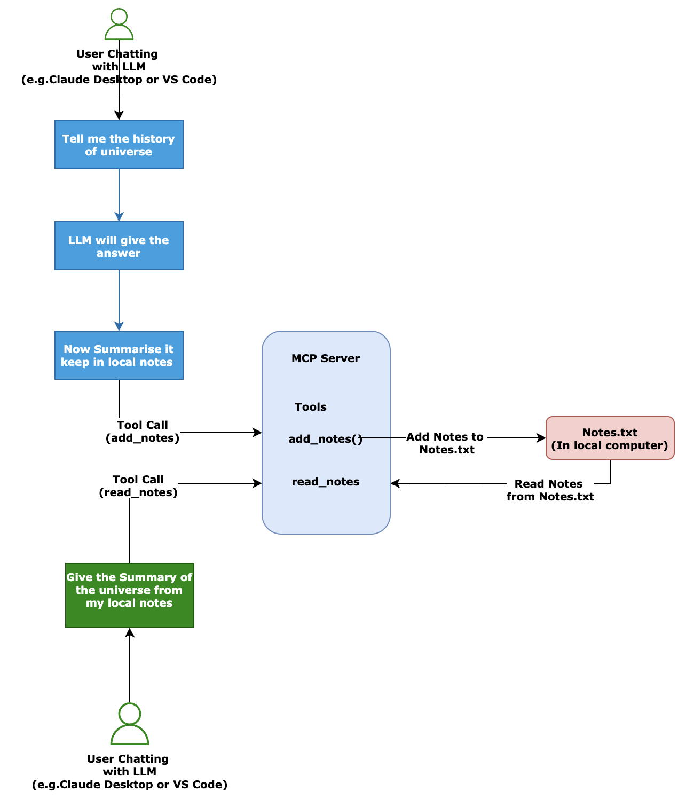

This enable an **LLM (Large Language Model)** to:

* **Store notes** in a local text file (Notes.txt).
* **Retrieve notes** from that file later, even across different sessions or tools.

Step-by-Step Functionality

* The MCP server will runs locally using **Stdio transport**, which allows direct communication between the LLM client and the server.
* The server exposes **functions (endpoints)** that the LLM can call.

Core MCP Tools

|  |  |
| --- | --- |
| add_notes() | read_notes() |
| **Purpose**: Append summarized content to Notes.txt.  **Workflow**:  LLM receives a user command like: “Summarize this and add to my notes.”  LLM calls the MCP server’s add_note() function.  The tool:   * Opens Notes.txt in **append mode**. * Writes the summarized text with a timestamp or context tag. * Confirms success back to the LLM. | **Purpose**: Retrieve stored notes from Notes.txt.  **Workflow**:  LLM receives a user command like: “Show me my notes.”  LLM calls the MCP server’s read_notes() function.  The tool:   * Opens Notes.txt in **read mode**. * Returns the entire content or filtered content (e.g., by date or keyword). * LLM displays the notes to the user. |

### PROJECT SET UP

* Setup the project using “**uv**”
* Create a python file e.g. “**locals.py**”
* Create a text file to store the summary – **notes.txt**

|  |
| --- |
| from mcp.server.fastmcp import FastMCP  mcp = FastMCP("LocalNotes")  @mcp.tool()  def add_note(note: str) -> str:  '''  Adds a note to the local notes storage.  Args:  note (str): The note to be added.  Returns:  str: Confirmation message.  '''  with open("notes.txt", "a",encoding="utf-8") as f:  f.write(note + "\n")  return "Note added successfully."  @mcp.tool()  def read_notes() -> str:  '''  Retrieves all notes from the local notes storage.  Returns:  str: All notes concatenated into a single string.  '''  try:  with open("notes.txt", "r",encoding="utf-8") as f:  notes = f.readlines()  return "".join(notes)  except FileNotFoundError:  return "No notes found."    if __name__ == "__main__":  mcp.run() |

#### VALIDATE IN MCP INSPECTOR

add_notes()

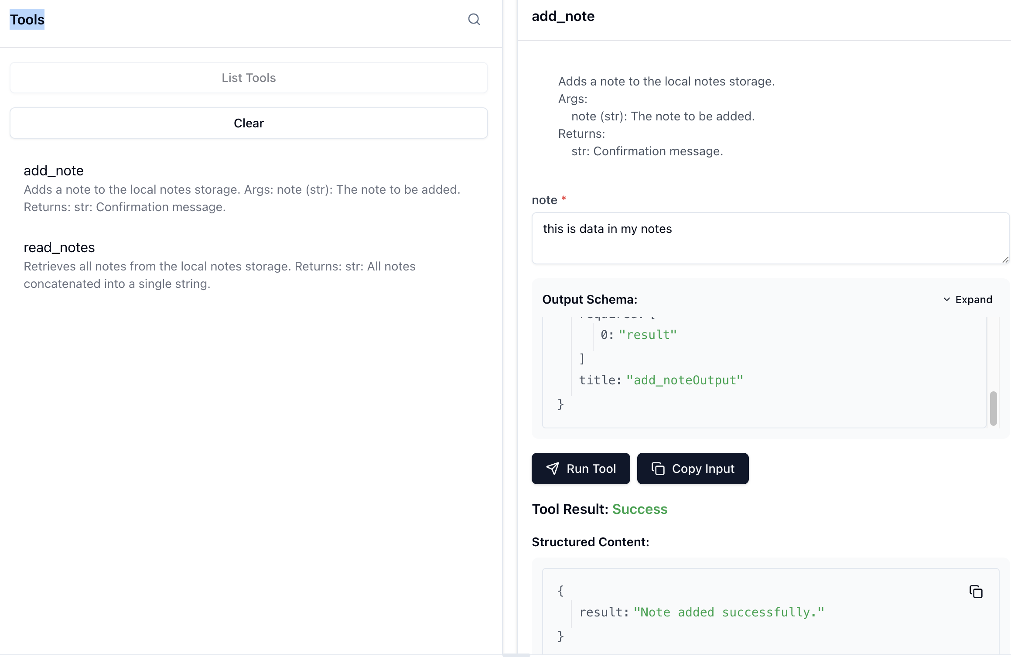

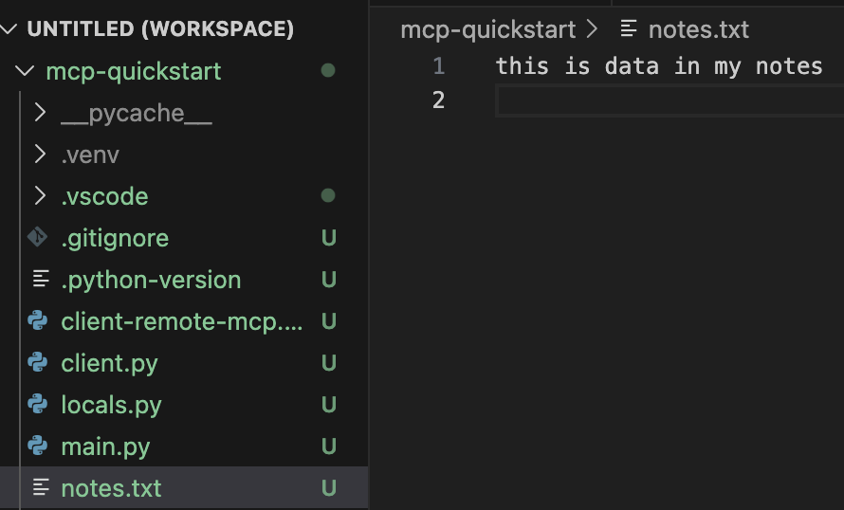

read_notes()

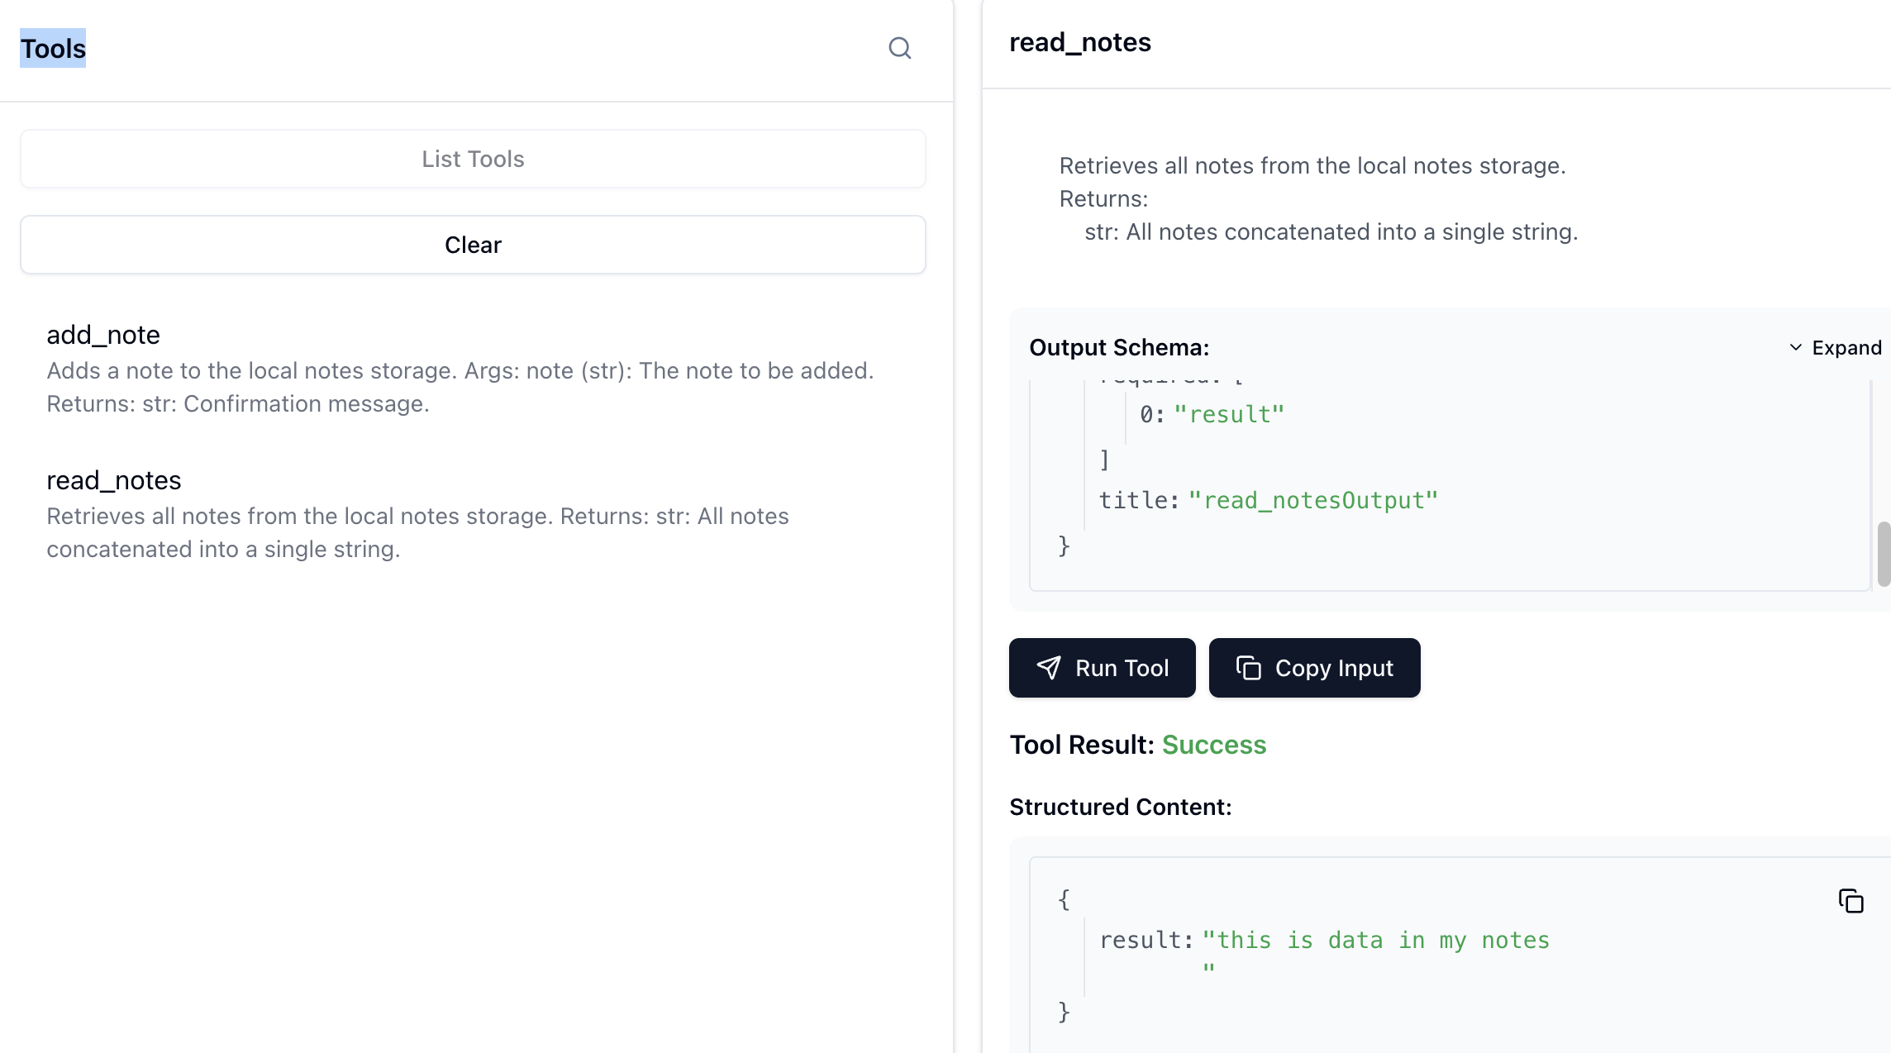

### TESTING WITH MCP HOST/CLIENT – VS CODE

* Add the following in the **mcp.json🡪 Then start the server**

|  |  |
| --- | --- |
|  | {  "servers": {  "local_notes_mcp": {  "command": "uv",  "args": [  "--directory",  "/Users/asinha37/code/MCP/mcp-quickstart",  "run",  "locals.py"  ]  }  }  } |

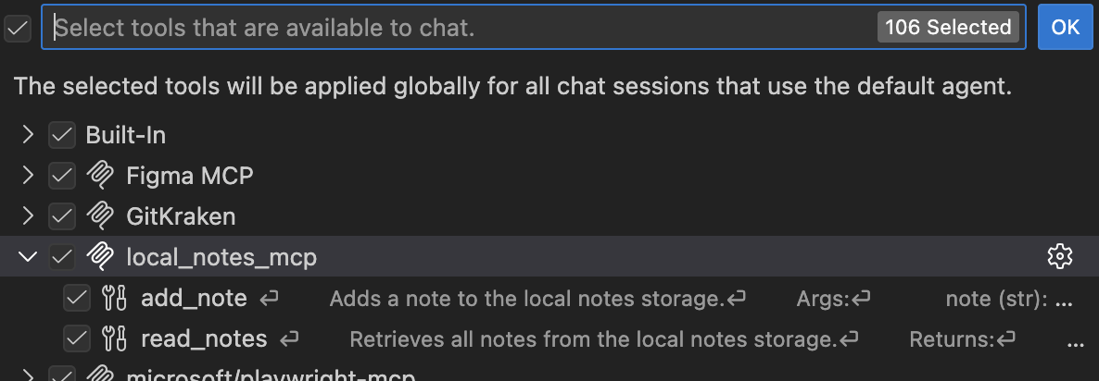

|  |  |
| --- | --- |
| * In this step we will add summary to notes.txt file of 2 conversations. But ask the LLM to give the summary of 1st conversation | |
|  |  |

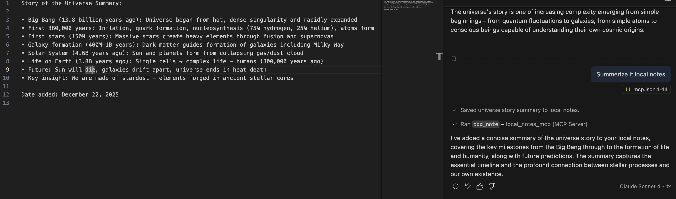

READ SUMMARY – read_notes()

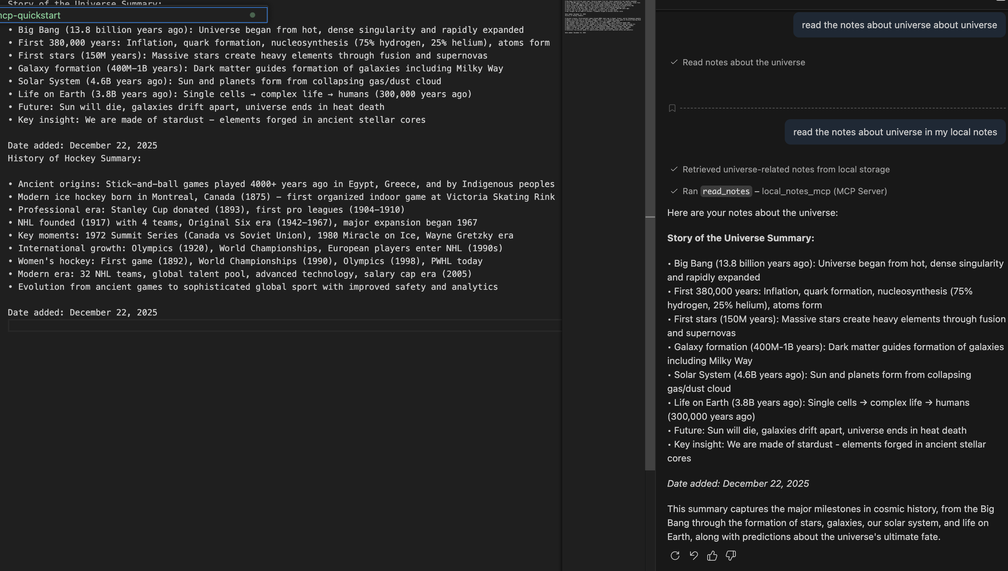

|  |  |
| --- | --- |
|  | NOTE:   * Any MCP client that is configured to use the same MCP server can **read and write to the same local file**. * This enables **cross-client persistence**:   + We can add notes while chatting with Claude Desktop.   + Later, we can read those notes in VS Code (or any other MCP-enabled client). * This creates a **shared memory layer** across different LLMs and tools without needing a cloud database—just a local file. |

### REST API USING MCP (STDIO)

|  |
| --- |
| For this example – we will make use of **CoinGecko** api   * **Endpoint -** https://api.coingecko.com/api/v3/simple/price?ids={symbol}&vs_currencies=usd * This API retrieves the **current price** of one or more cryptocurrencies in a specified fiat currency (in this case, USD).   **Parameters**   * **ids**   + Represents the cryptocurrency identifier (symbol or name used by CoinGecko).   + Example: bitcoin, ethereum, dogecoin.   + You can pass multiple IDs separated by commas:\ ids=bitcoin,ethereum. * **vs_currencies**   + The fiat or crypto currency you want the price in.   + Example: usd, eur, inr.   + You can also request multiple currencies:\ vs_currencies=usd,eur.   **Example Requests**  Request - <https://api.coingecko.com/api/v3/simple/price?ids=bitcoin&vs_currencies=usd>  **Response -** {"bitcoin":{"usd":89634}}  Request - <https://api.coingecko.com/api/v3/simple/price?ids=bitcoin&vs_currencies=usd,eur>  Response - {"bitcoin":{"usd":89626,"eur":76378}} |

MCP SERVER CODE

|  |
| --- |
| from mcp.server.fastmcp import FastMCP  import requests  mcp = FastMCP("Crypto")  @mcp.tool()  def get_crypto_price(cryptos: str, vs_currencies: str = "usd") -> str:  '''  Retrieves the current price of the specified cryptocurrencies.  Args:  cryptos (str): Comma-separated cryptocurrency names (e.g., "bitcoin,ethereum").  vs_currencies (str): Comma-separated currencies to compare against (default: "usd").  Returns:  str: The current prices of the cryptocurrencies.  '''    url = f"https://api.coingecko.com/api/v3/simple/price?ids={cryptos}&vs_currencies={vs_currencies}"  response = requests.get(url)  data = response.json()  results = []  crypto_list = [crypto.strip() for crypto in cryptos.split(',')]    for crypto in crypto_list:  if crypto in data:  currencies = vs_currencies.split(',')  prices = []  for currency in currencies:  if currency.strip() in data[crypto]:  price = data[crypto][currency.strip()]  prices.append(f"{price} {currency.strip().upper()}")  if prices:  results.append(f"{crypto.upper()}: {', '.join(prices)}")  else:  results.append(f"Cryptocurrency '{crypto}' not found.")    return "\n".join(results) if results else "No valid cryptocurrencies found."  if __name__ == "__main__":  mcp.run() |
| **mcp.json** |
| {  "servers": {  "crypto_mcp": {  "command": "uv",  "args": [  "--directory",  "/Users/asinha37/code/MCP/mcp-quickstart",  "run",  "crypto.py"  ]  }  }  } |

#### TESTING APPLICATION

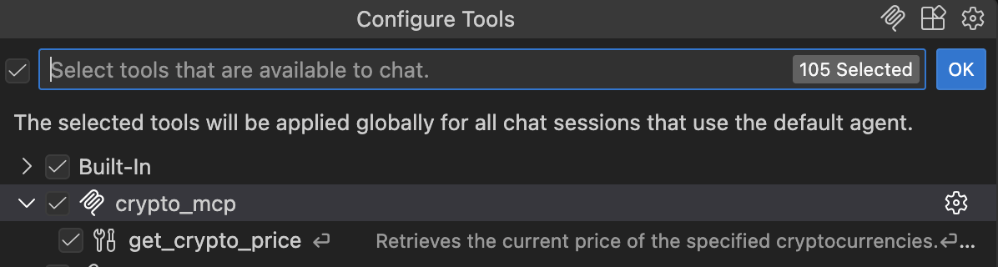

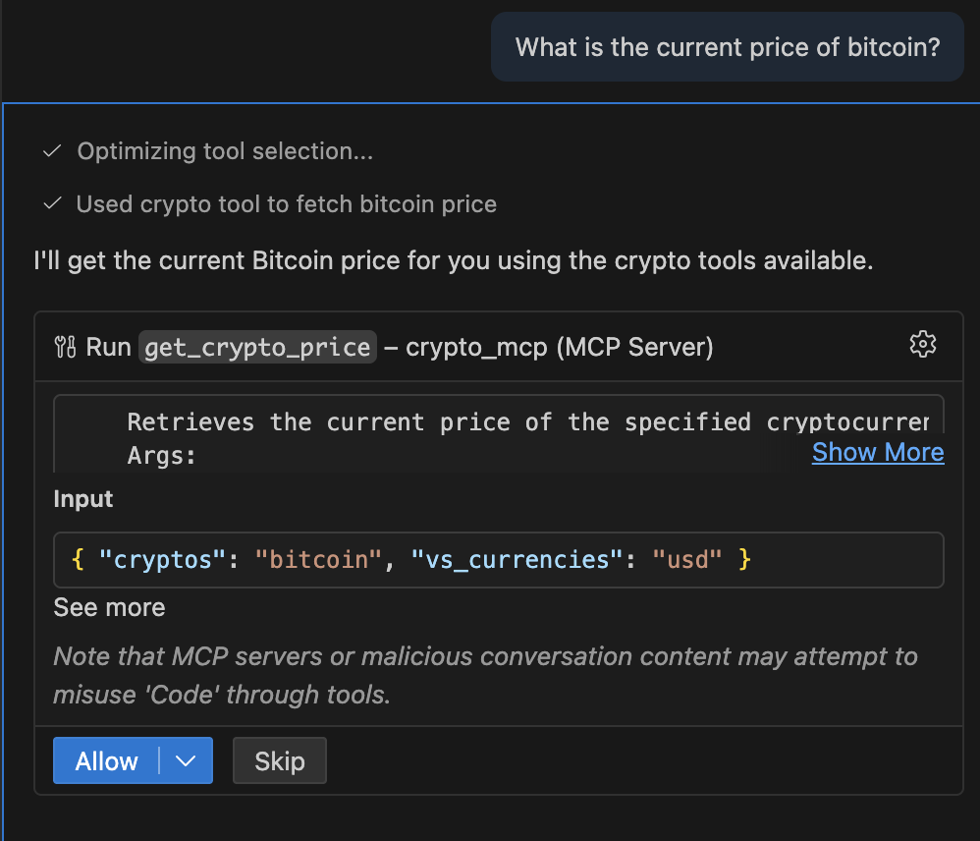

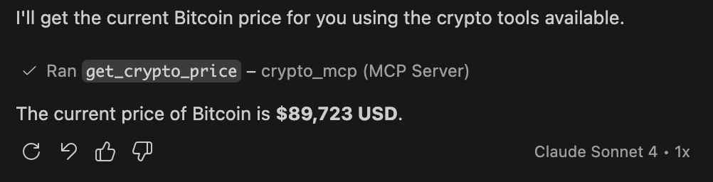

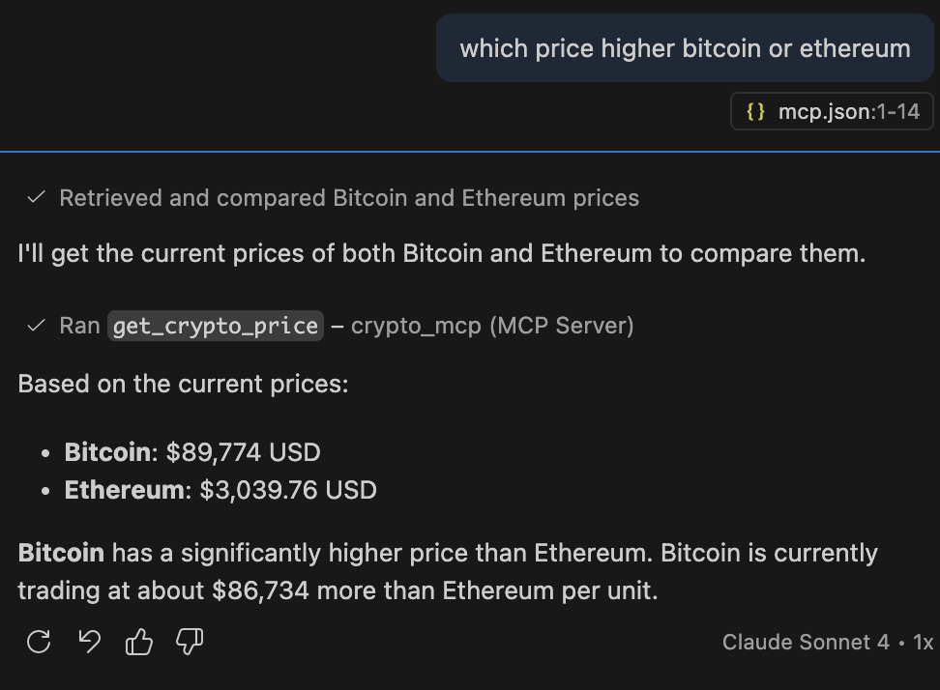

Why Make APIs MCP-Compatible?

* Wrapping any API inside an **MCP server** makes it universally accessible to any MCP-enabled client (LLMs, IDEs, chat tools) without requiring custom integration for each client.
* When the underlying API changes (e.g., endpoint updates, new parameters):
  + Contributors update the MCP server code in the GitHub repository.
  + Users who install or update the MCP server automatically get the latest version.
  + This ensures **continuous compatibility** without manual intervention.

### COMPLEX INPUTS FOR MCP SERVERS

MCP Tools Are Flexible

* MCP Servers support more than just simple strings or integers.
* Pedantic is a schema and data validation library in Python. It allows us to define custom input types, which MCP clients and servers can use effectively.
* When a function requires multiple related fields or complex data, passing them as separate arguments becomes messy.
* A **custom schema** groups these fields into one object, making input handling cleaner and more consistent.
* MCP clients can read the schema and automatically craft the correct input format.

|  |
| --- |
| from mcp.server.fastmcp import FastMCP  from pydantic import BaseModel,Field  from typing import List  mcp = FastMCP("ComplexInputs")  class Person(BaseModel):  first_name: str = Field(..., description="The person's first name")  last_name: str = Field(..., description="The person's last name")  year_of_experience: int = Field(..., description="Years of experience in their field")  previous_addresses: List[str] = Field(default_factory=list, description="List of previous addresses")  @mcp.tool()  def add_person_member_database(person: Person) -> str:  '''  Adds a person to the member database.  Args:  first_name (str): The person's first name.  last_name (str): The person's last name.  year_of_experience (int): Years of experience in their field.  previous_addresses (List[str]): List of previous addresses.  Returns:  str: Confirmation message.  '''  # Log the person to log.txt  with open("log.txt", "a") as f:  f.write(f"Added {person.first_name} {person.last_name} with "  f"{person.year_of_experience} years of experience "  f"and previous addresses: {', '.join(person.previous_addresses)}\n")    return (f"Added {person.first_name} {person.last_name} with "  f"{person.year_of_experience} years of experience "  f"and previous addresses: {', '.join(person.previous_addresses)} to the database.")  if __name__ == "__main__":  mcp.run() |

#### TESTING APPLICATION

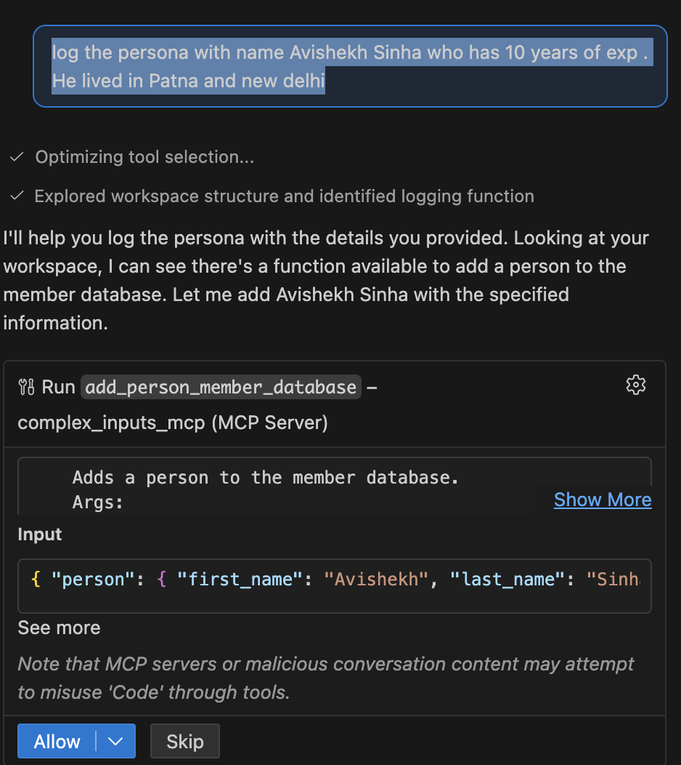

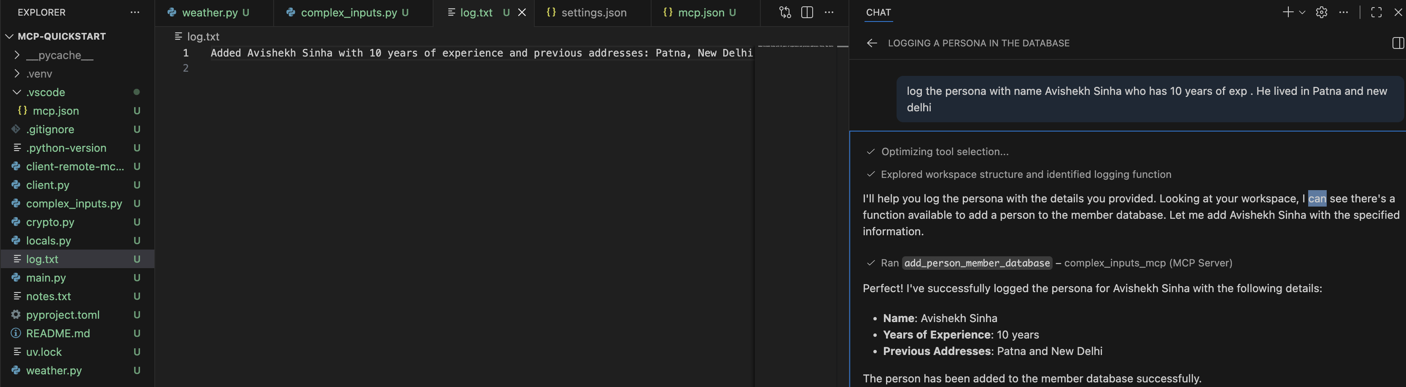

# MCP CLIENT - DEEP DIVE

## CREATING MCP CLIENT USING OPENAI-SDK

* Documentation Link - <https://openai.github.io/openai-agents-python/quickstart/>

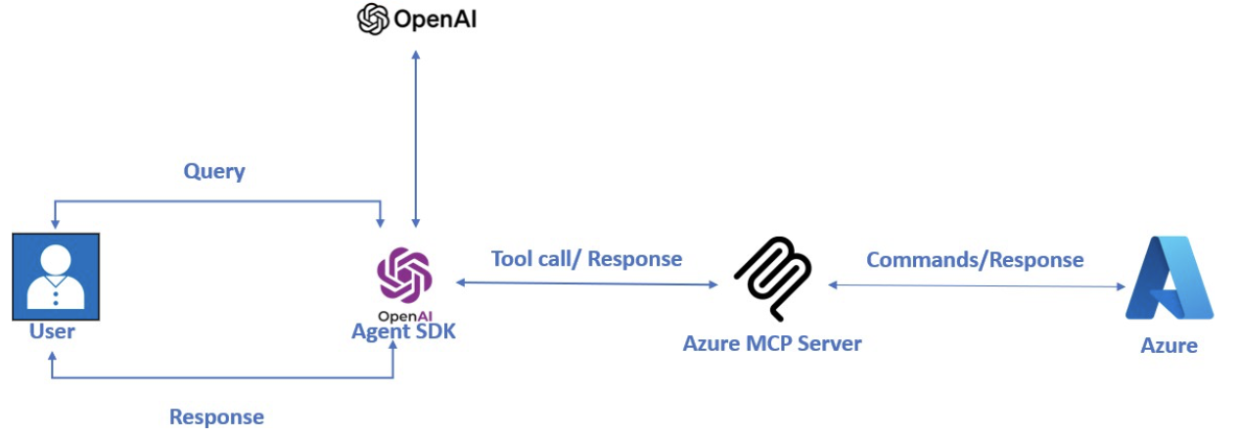

# MCP RESOURCES

# MCP PROMPTS

# MCP DEPLOYMENT

**There are 2 Distribution Approaches**

**1**. Local Installation

1. Package the MCP server into a distributable format.
2. Publish it online for download.
3. Provide an installation script for MCP clients.
4. Users install and run the server locally, enabling interaction with their LLM.

**2**. Remote Hosting (Covered in next module)

1. Host the MCP server on a virtual machine or website.
2. MCP clients connect via **Streamable HTTP** protocol.
3. No local installation required.

### **LOCAL INSTALLATION**

* For existing MCP servers, such as the Airbnb MCP server (https://github.com/openbnb-org/mcp-server-airbnb), the MCP server can be accessed using the "npx" command.
* This command downloads the MCP server and runs it locally.
* Once the MCP server is running on local machine, the MCP client is able to communicate with the MCP server.
* Note – We can use able to **npx** because it’s a node package(using nodejs , typescript /javascript)

**For this setup – for our custom MCP server – we need a package manager**

* Let’s say – we have MCP server developed in Python we can use “**uvx**” . We will use GIT as our package manager.mcp

**STEPS**

Creating the MCP Server:

1. Started in a blank folder and opened the terminal.
2. Used ***uv init*** to create a new project.
3. Create the virtual environment – **uv venv**
4. Added necessary libraries with ***uv add ‘[mcp-cli]’***.
5. Set up and activated a virtual environment.

Organizing the Project Structure

**Followed standard Python packaging format.**

|  |  |
| --- | --- |
| 1. Root folder: Contains *pyproject.toml* with project details (name, version, dependencies). 2. Create **src** folder: Holds application code. 3. **mcp_server folder** within src:    1. ***__init__.py***: Marks as a package.    2. ***__main__.py***: Entry point for running the server.    3. ***server.p****y*: Main server logic (includes a simple calculator). |  |

Setting Up the Entry Point:

* Defined an entry point function in *__main__.py* to start the MCP server.
* Script imports server logic from *server.py* and runs it.

|  |  |
| --- | --- |
| **server.py** | |
| from mcp.server.fastmcp import FastMCP  # Create the FastMCP server  mcp = FastMCP("Calculator")  @mcp.tool()  def add(a: float, b: float) -> float:  """Add two numbers together    Args:  a: The first number  b: The second number    Returns:  The sum of a and b  """  return a + b  @mcp.tool()  def subtract(a: float, b: float) -> float:  """Subtract b from a.    Args:  a: The first number  b: The number to subtract    Returns:  The difference of a and b  """  return a - b | @mcp.tool()  def multiply(a: float, b: float) -> float:  """Multiply two numbers together.    Args:  a: The first number  b: The second number    Returns:  The product of a and b  """  return a * b  @mcp.tool()  def divide(a: float, b: float) -> float:  """Divide a by b.    Args:  a: The dividend  b: The divisor    Returns:  The quotient of a divided by b    Raises:  ValueError: If b is zero  """  if b == 0:  raise ValueError("Cannot divide by zero")  return a / b |
| **__main__.py –** The entry point file | from mcpserver.server import mcp  def main():  mcp.run()  if __name__ == "__main__":  main() |

### COMMIT THE CODE IN GITHUB

* Since we are using GitHub as package manager 🡪 Commit the code
* GitHub URL : <https://github.com/avishekhsinhaRepo/mcp-deployment.git>

### PREPARING FOR DEPLOYMENT

|  |  |
| --- | --- |
| * Update ***pyproject.toml*** * This file makes your MCP server project **packaged, installable, and ready for distribution**—aligning perfectly with the module you studied about packaging and distributing MCP servers.   **Purpose of** pyproject.toml   * This file defines the **metadata**, **dependencies**, and **build configuration** for a Python project. * It’s part of the modern Python packaging standard (PEP 518/621). * It tells tools like pip and setuptools how to build and install your project. | [project]  name = "mcp-deployment"  version = "0.1.0"  description = "Add your description here"  readme = "README.md"  requires-python = ">=3.10"  dependencies = [  "mcp[cli]>=1.25.0",  ]  [project.scripts]  mcp-server = "mcpserver.__main__:main"  [build-system]  requires = ["setuptools"]  build-backend = "setuptools.build_meta"  [tool.setuptools]  package-dir = {"" = "src"}  [tool.setuptools.packages.find]  where = ["src"] |

#### **BREAKDOWN OF SECTIONS**

**[project]**

|  |  |
| --- | --- |
| **name = "mcp-deployment"** | * The name of package. * This is what users will install via pip install mcp-deployment. |
| **version = "0.1.0"** | The initial version of your project. Follows semantic versioning. |
| **description = "Add your description here"** | A short summary of what your project does. |
| **readme = "README.md"** | Points to the README file for detailed documentation. |
| **requires-python = ">=3.10"** | Specifies the minimum Python version required. |
| **dependencies = [ "mcp[cli]>=1.25.0", ]** | Lists runtime dependencies. Here, the project depends on the MCP library (with CLI extras) version 1.25.0 or higher. |

**[project.scripts]**

|  |  |
| --- | --- |
| **mcp-server = "mcpserver.**main**:main"** | * Defines a **console script entry point**.(Entry Point file) * When installed, users can run mcp-server from the command line, which calls the main() function in mcpserver/__main__.py. |

**[build-system]**

|  |  |
| --- | --- |
| **requires = ["setuptools"]** | Indicates that setuptools is needed to build the project. |
| **build-backend = "setuptools.build_meta"** | Specifies the backend used for building the package. |

**[tool.setuptools]**

|  |  |
| --- | --- |
| **package-dir = {"" = "src"}** | Tells setuptools that the source code is inside the src directory. |

**[tool.setuptools.packages.find]**

|  |  |
| --- | --- |
| **where = ["src"]** | Instructs setuptools to look for packages inside the src folder. |

What This Configuration Does

1. Organizes your project using the **src layout** (recommended for modern Python projects).
2. Creates an installable package named mcp-deployment.
3. Installs a CLI command mcp-server for easy execution.
4. Ensures proper dependency management and build process.

### USING THE DEPLOYED MCP SERVER – IN VC CODE HOST

1. Select **stdio**

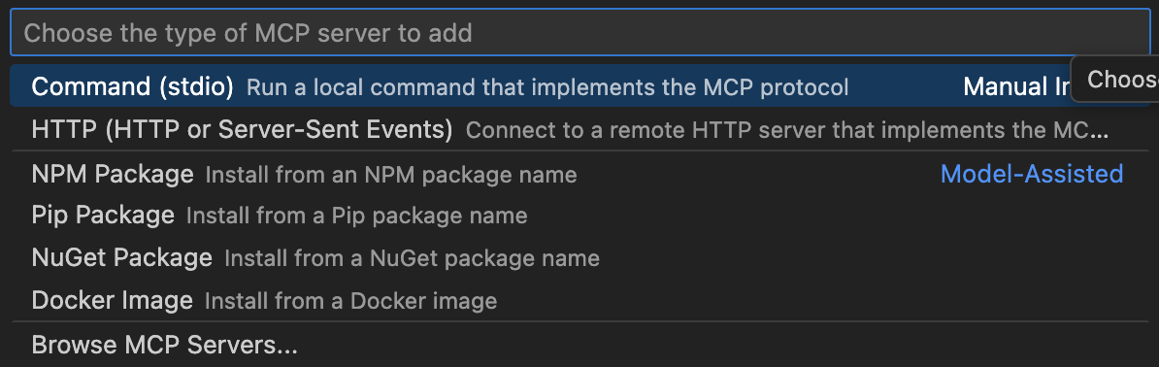

1. Enter the command : **uvx --from git+https://github.com/avishekhsinhaRepo/mcp-deployment.git mcp-server**

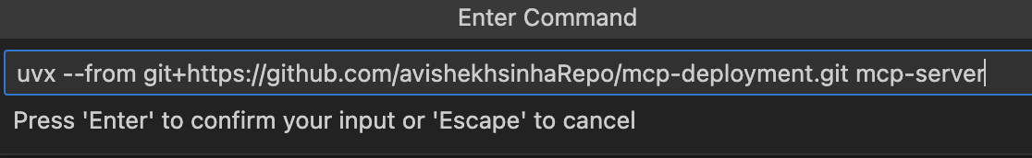

1. Give the ID of the MCP Server ID

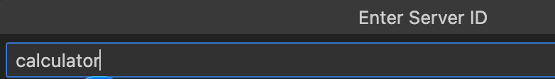

This will add below configuration mcp configuration

|  |  |
| --- | --- |
|  | * We can add the below configuration Globally or within the workspace * Adding it globally will add configuration in a global mcp..json file * Adding it workspace level will create a .vscode folder with mcp.json file within |

|  |
| --- |
| "calculator": {  "type": "stdio",  "command": "uvx",  "args": [  "--from",  "git+https://github.com/avishekhsinhaRepo/mcp-deployment.git",  "mcp-server"  ]  } |

### INVOKING TOOLS

|  |  |
| --- | --- |
| * **Start the server** * **Invoke the tool – Add 40 and 30** |  |

# STDIO VERSUS STREAMABLE HTTP

STDIO (Standard Input/Output)

* MCP client starts the server as a **local subprocess** and they communicate by writing **JSON lines** to stdin and stdout.Hence both servers runs locally in a single machine
* No authorization required as it running locally.
* **Ideal for:** Local tools and CLIs; simple and fast.
* **Limitations:** Single client only, no web access.

HTTP (Streamable)

* MCP server runs as a **regular HTTP service** with **one /mcp endpoint**.
* Client sends requests using **HTTP POST** and can receive **streamed updates** (via **SSE**) in the same response or through a **long-lived GET**.

**ADVANTAGES:**

1. Scales to **multiple clients**
2. **Cloud-friendly**
3. Supports **notifications and streaming**
4. **Improvement:** Replaces older **HTTP + SSE dual-endpoint** design.

|  |
| --- |
| What is “Streamable HTTP”?  Think of two ways to communicate:   * **STDIO = Talking to a tool you launched locally**   + We say something (**write JSON to stdin**).   + It replies (**writes JSON to stdout**).   + It’s one private conversation; **super low overhead**. * **Streamable HTTP = Talking over the web with live updates**   + We **POST** a JSON-RPC message to /mcp.   + The server can reply immediately **or stream multiple messages back** (SSE) as the task progresses.   + The server can also keep a **GET stream open** to push **notifications** to the client (optional).   + All clients use the **same endpoint**; we can have **many clients at once**. |

### CREATING HTTP-STREAMABLE MCP SERVER

|  |
| --- |
| from mcp.server.fastmcp import FastMCP  mcp = FastMCP("server")  @mcp.tool()  def greet(name: str) -> str:  return f"Hello, {name}!"  if __name__ == "__main__":  mcp.run(transport="streamable-http") |

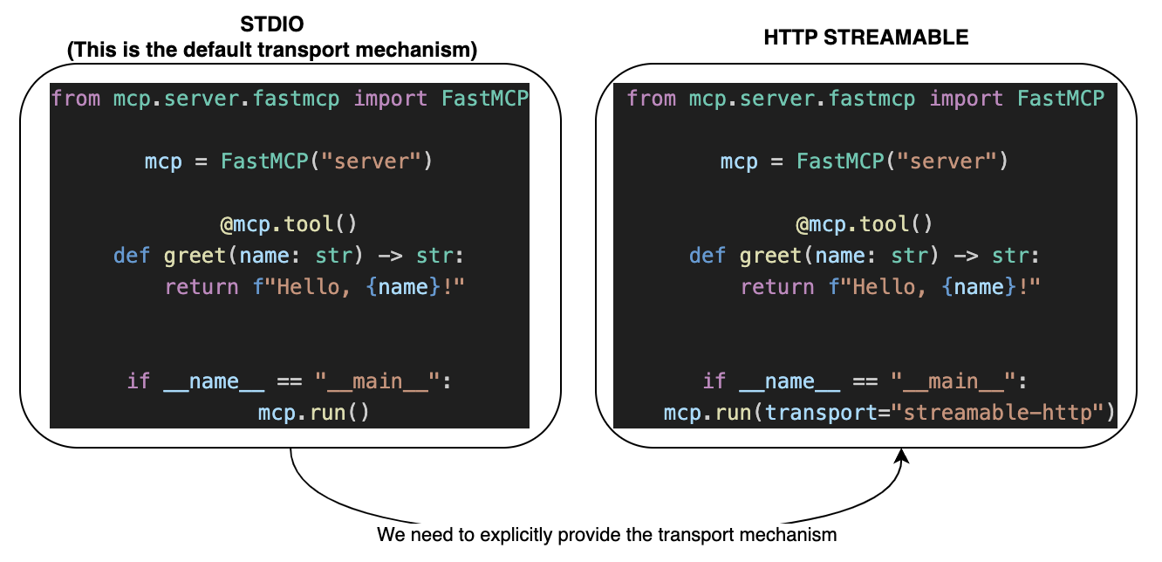 TESTING HTTP-STREAMABLE MCP SERVER USING MCP INSPECTOR

1. **Step 1: Start the MCP server : uv run <file_name>**

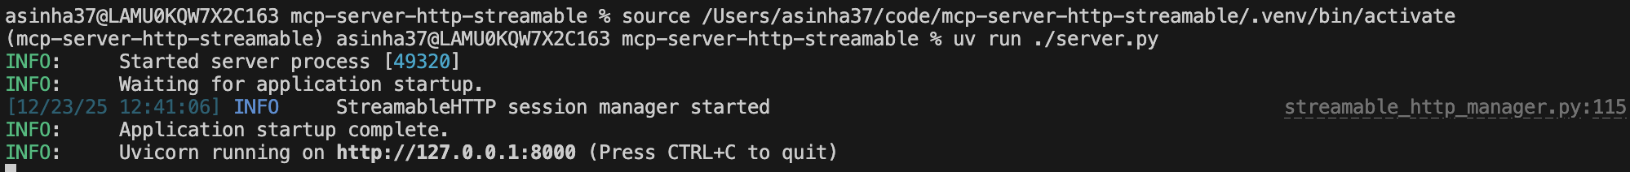

NOTE: The server is running : <http://127.0.0.1:8000/>

1. Step 2: Open a new terminal 🡪 Start the MCP inspector: **mcp dev <file_name>**

|  |  |
| --- | --- |
| TRANSPORT TYPE | <http://127.0.0.1:8000/>mcp |
| * Note we need to add “/mcp” prefix 🡪 Connect | |

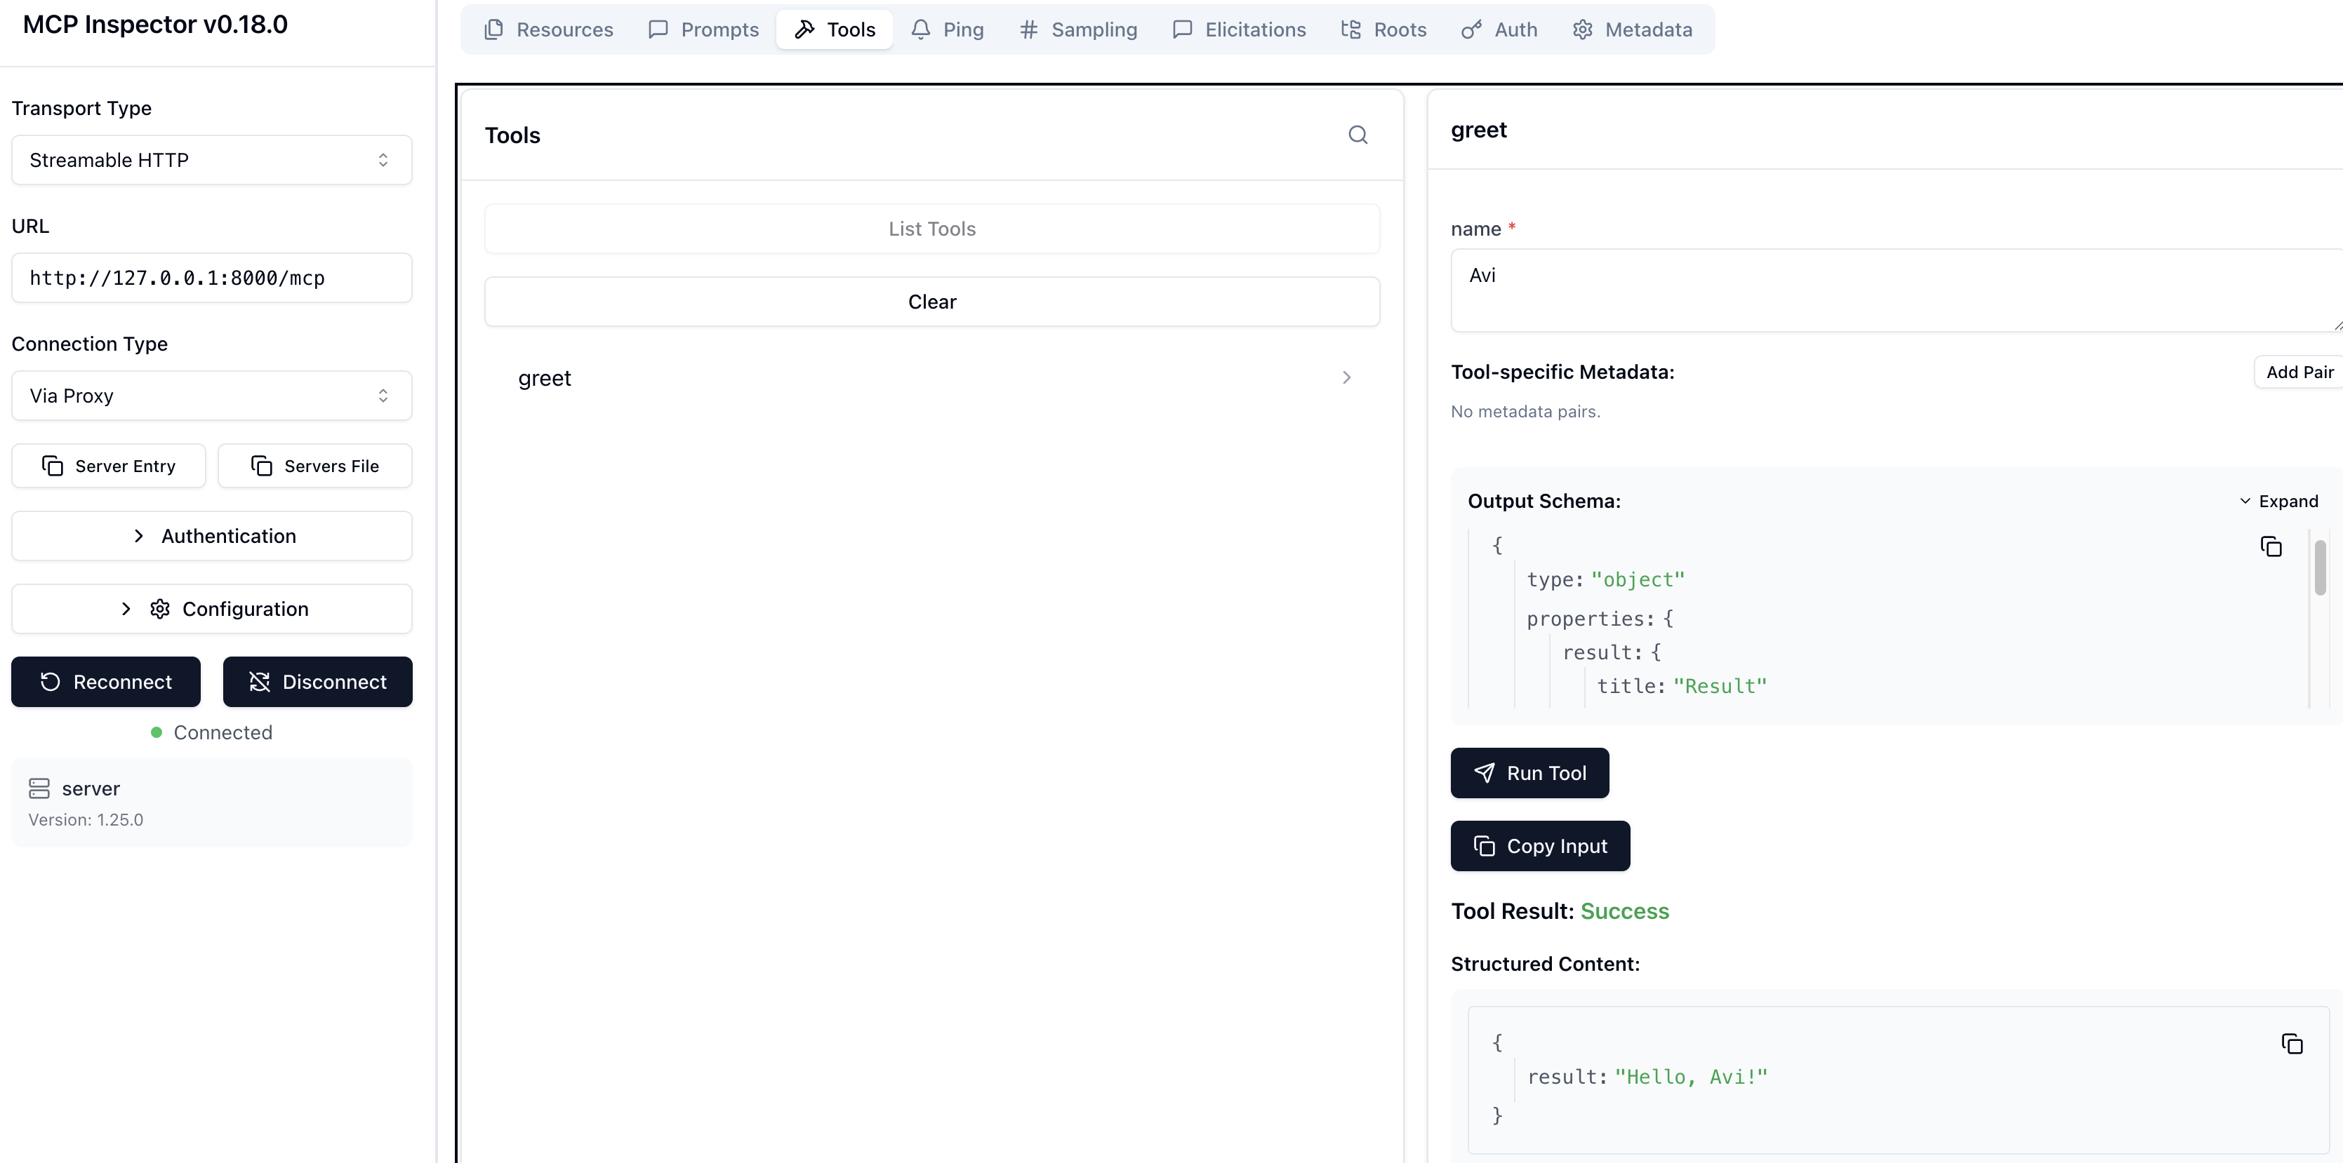

### TESTING HTTP-STREAMABLE MCP SERVER USING GITHUB COPILOT CHAT

NOTE : VS Code(MCP Client) has support for HTTP Streamable MCP Servers

* Step 1: Click on tools icon in Copilot Chat 🡪 Select HTTP

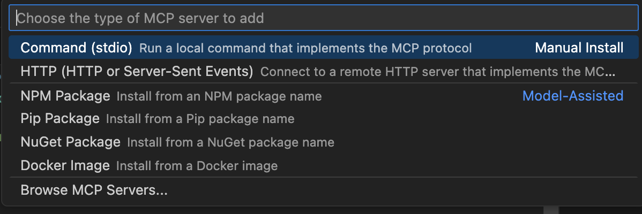

|  |  |
| --- | --- |
| * Step 2: Give the URL and MCP server ID. * Configure the Server URL - <http://127.0.0.1:8000/mcp> * Note the URL will be suffixed with **/mcp** |  |
| * Enter the Server ID |  |
| * Step 3: Based on preferences select where we want to add the MCP server. Let’s select “**Global**” |  |

|  |  |
| --- | --- |
| * This will add the MCP configuration in global “mcp.json” file. * Start the Server |  |
|  |  |

### TESTING HTTP-STREAMABLE MCP SERVER USING mcp-remote PACKAGE

NOTE : mcp-remote node package can be used on those mcp client that does not HTTP streamable support

1. Start the mcp server : uv run <file_name> 🡪 uv run server.py
2. Note the URL & PORT where the MCP server in running
3. Create **mcp.json in <project_root>/.vscode directory**

|  |  |  |
| --- | --- | --- |
| **mcp.json** | | |
| {  "servers": {  "greet_http_streamable_mcp": {  "command": "npx",  "args": [  "mcp-remote",  "http://127.0.0.1:8000/mcp",  "--allow-http",  ]  }  }  }   * Note: Since the MCP sever is running locally hence we need to explicitly allow “http” protocol | * We will use “mcp-remote” npm package * Configure the Server URL and start the server  * <http://127.0.0.1:8000/mcp> * Note the URL will be suffixed with **/mcp** |  |

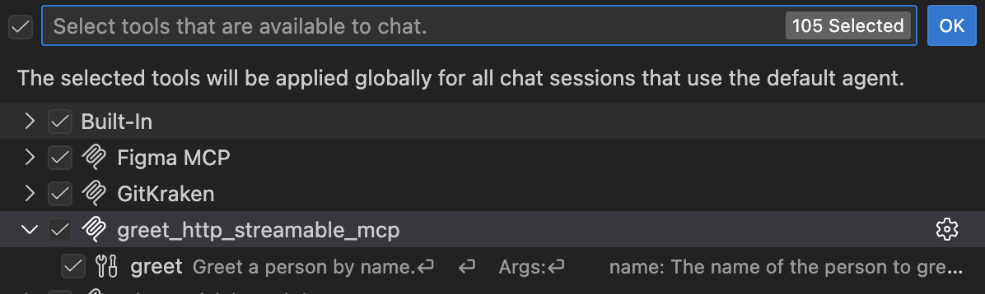

Github Copilot Chat Response

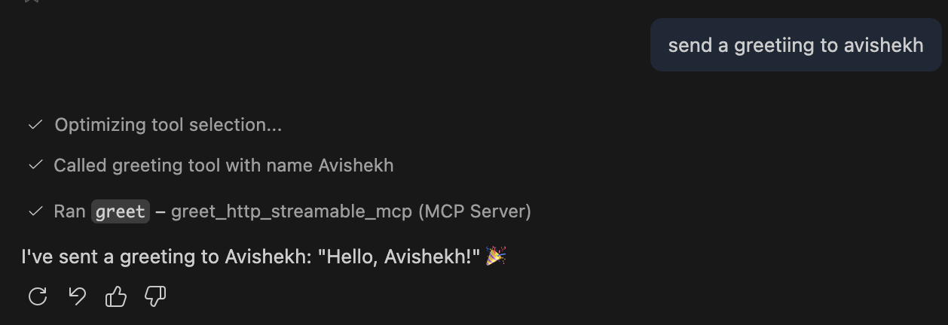

# MCP PROJECTS

## MCP - MEMORY TRACKER

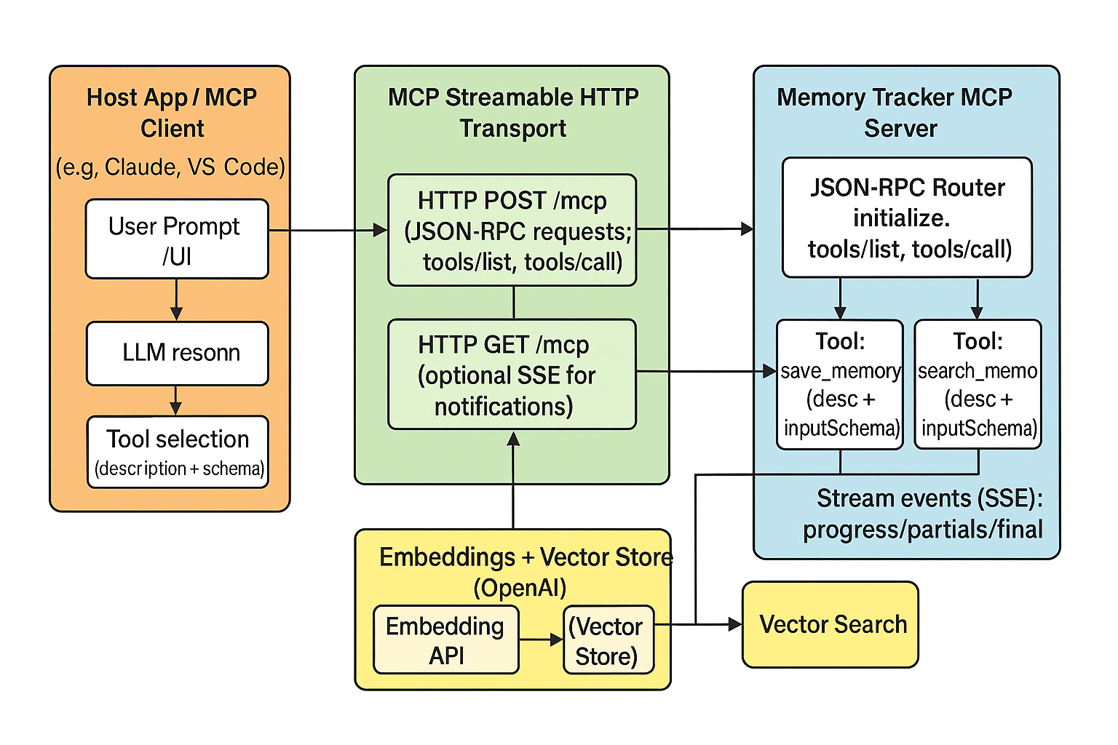

Build an **MCP server** that can **save** and **retrieve** user “memories” (short texts describing interactions or preferences) using **vector embeddings** for semantic search.

The server exposes MCP **tools** for:

1. **Create/save memory** → embeds text and stores it in a **vector store**.
2. **Search memory** → semantically searches the vector store and returns relevant memory content.

Key points:

* Uses **OpenAI embeddings / vector store** for scalable, cost‑effective storage & retrieval.
* Demonstrates testing via **MCP Inspector**, and mentions integration with **Claude** and **VS Code** as host clients.
* Shows practical scenarios (e.g., trip planning, recalling preferences like “my favorite pizza topping is jalapenos” as a stored memory).
* Covers local vs. remote deployment notes and config.json adjustments.

What each block does (quick reference)

**Host Client (Claude/VS Code)**:

Calls tools/list to get **tool descriptions + schemas**.

The LLM uses **descriptions** and **inputSchema** to decide whether to call save_memory or search_memory. [[MCP+Server…+Tracker+2 | PDF]](https://uhgazure-my.sharepoint.com/personal/avishekh_sinha_optum_com/Documents/Microsoft%20Copilot%20Chat%20Files/MCP+Server+Build+Memory+Tracker+2.pdf)

**Transport (Streamable HTTP)**:

Client sends each JSON‑RPC message via **POST /mcp**; server can reply with a **single JSON** or **SSE stream** of multiple events.

Optional **GET /mcp** SSE stream for server‑initiated notifications. (This mirrors how the docs test with MCP Inspector and how you’d scale to multi‑client scenarios.)

**Server (Memory Tracker)**:

tools/list returns **save_memory** and **search_memory** with their schemas.

tools/call routes the call, emits **progress** events while working, then returns the final result.

**Vector Store (OpenAI)**:

save_memory: embed input text and upsert to the **vector store**.

search_memory: run a vector similarity **query** and return matched memories (e.g., the jalapeños example).

¸